IOMEDICAL EQUIPMENT MANAGMENT & MAINTENENCE PROGRAMME
FOR
INDIAN STATES
A JOINT STUDY BY
MASS BIOMEDICALS PVT. LTD.
(AN ISO 13485: 2003 CERTIFIED COMPANY)
&
NATIONAL HEALTH SYSTEMS RESOURCE CENTRE,
(MINISTRY OF HEALTH AND FAMILY WELFARE, Govt. Of India)
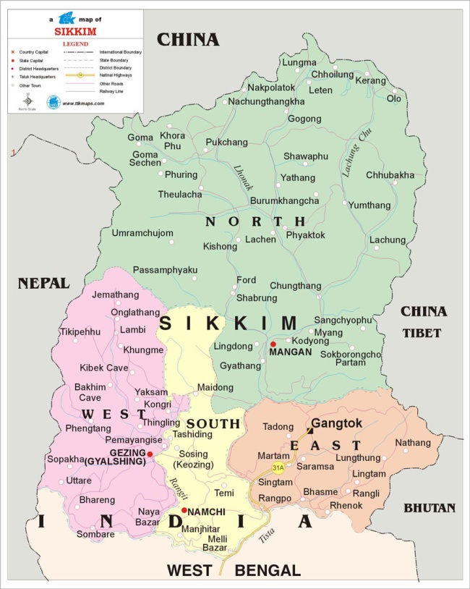
STUDY REPORT ON BIOMEDICAL EQUIPMENT MANAGEMENT IN
East & North DISTRICT
STATE of SIKKIM
(February- 2015)

ACKNOWLEDGEMENT

I feel extremely hounored to be a part for the 4th time for Research Study of BIOMEDICAL EQUIPMENT MANAGMENT & MAINTENENCE PROGRAMME on behalf of Ministry of Health and Family Welfare, Government of India..
I sincerely convey our gratitude to Dr Sanjeev Kumar Dixit, the Executive Director, NHSRC & Dr Jitendra Sharma, Senior Consultant & Head, Health Technology Division, for choosing us their partner for Biomedical Equipment mapping in the State of Sikkim.
My sincere thanks go to Dr. K. Bhandari, Secretary (Health Care, Human Services & Family Welfare), Department of Health & Family Welfare, Government of Sikkim, Mission Director, Dr. P.M. Pradhan and Mr. Rakesh Sundus for their whole hearted support and help at each stage to conduct of study smoothly.
I am indeed indebeted to Dr. Yogesh Verma, Prrincipal & Medical Superintendent of STNM Hospital who shared lots of informations in between his busy shedule. Our sincere thanks goes to Ms. Tsing Doma, Store In-charge STNM Hospital and Mr. Passang and many off site staff and experts for smoooth conduct of very important Study on ground for their most valuable support. We are specailly thankful to Mr. Prabhat Arora and all staff memebers of Health Technology Division, NHSRC for their overwheming support in smooth conduct of this major project , without which, it would not have been possible to complete this comprehensive study. It may be submitted that all team members and support staff whose name not mentioned also deserve compliment for completion of study in record period of time.
I am also thankful to my ground staff and all my members for their tireless efforts and working in all adverse conditions to make this project meaningful.

1st March’2015
S. Chakraborty New Delhi Director
Mass Biomedicals Pvt. Ltd.

TABLE OF CONTENTS

List of Abbreviations - 3
Executive Summary - 8
Chapter I - Terms of Reference of Project Study - 10
Chapter II - Introduction - 14
Chapter III - Aim and Objectives of the study - 23
Chapter IV- Literature review - 25
Chapter V - Research Project Methodology - 27
Chapter VI - Research Study Findings & Analysis - 29
Chapter VII- Discussion - 31
Chapter VIII- Recommendation & Conclusion - 33
Chapter IX - Limitations of Study - 35
DETAILS OF CASE STUDY North District - 36
Summary of Biomedical Equipment Inventory Survey
in North District of Sikkim - 48

DETAILS OF CASE STUDY East District - 49
Summary of Biomedical Equipment Inventory Survey
in East District of Sikkim - 73

References - 74
Glossary - 76

LIST OF ABBREVIATIONS

AAMI Association for the Advancement of Medical Instrumentation

ABCE American Board of Clinical Engineering

BMET Biomedical Engineering Technologist

BMES Biomedical Engineering Specialist

CCE Clinical Engineering Certification

PET Position Emission Tomography

CHC Community Health Centre

CM Corrective Maintenance

CMMS Computerized maintenance management system

CT Computer Tomography

ECG Electro Cardiograpy

DH District Hospital
FDA Food and Drug Administration

GIHT Global Initiative on Health Technologies

MRI Magnetic Resonance Imaging

PACS Picture Archiving and Communication Systems
AAMI Association for Advancement of Medical Instrumentation
ACCE American College of Clinical Engineering
BMET biomedical equipment technician
CIMV conventional intermittent mandatory ventilation
CM corrective maintenance
CMMS computerized maintenance management system
ECG electrocardiograph
EM equipment management
FDA Food and Drug Administration
GIHT Global Initiative on Health Technologies
GOI Government of India
HEPA high efficiency particulate air
HTM health/health-care technology management
IPM inspection and preventive maintenance
ISO independent service organization
MOH&FW Ministry of Health and Family Welfare
MRI magnetic resonance imaging
NFPA National Fire Protection Association
PHC Primary Health Centre
PM preventive maintenance
PPE personal protective equipment
SIMV synchronized intermittent mandatory ventilation
TAGHT Technical Advisory Group on Health Technology
UPS uninterruptable power supply
WHO World Health Organization

COMMON ENGINEERING ABBREVIATIONS
Here is a comprehensive list of abbreviations used in the field of engineering:
- A - Ampere
- AB - As Built
- AC - Alternating Current
- A/C - Air Conditioning
- AFL - Above Floor Level or Above Finished Level
- AG - Agricultural Pipe Drain
- AGL - Above Ground Level
- AHU - Air Handler Unit
- APPROX - Approximately
- ASCII - American Standard Code for Information Interchange
- BSP - British Standard Pipe
- BT - Bath Tub or Boundary Trap
- BTM - Bottom
- CAD - Computer Aided Design
- CCTV - Closed Circuit Tele Vision
- CFW - Continuous Fillet Weld
- CHS - Circular Hollow Section
- CL - Center Line
- CLG - Control Joint
- CLR - Clearance
- CMU - Cement Masonry Unit
- CNJ - Construction Joint
- COL - Column
- COMMS - Communications
- CONN - Connection
- CONT - Continuous
- CT - Controller
- CTR - Center
- CTRL - Control
- CTRS - Centres
- DN - Diameter Nominal
- DP - Down Pipe
- DWG - Drawing
- ELEC - Electrical
- ECN or ECR - Engineering Change Note, Engineering Change Request
- EQ - Equal
- EQUIP - Equipment
- EW - Each Way
- EWB - Electric Water Boiler
- FL - Floor Level
- FOC - Fibre Optic Cable
- FS - Far Side
- FSBL - Full Strength Butt Weld
- FTG - Footing
- FTP - Fibre Termination Panel (fibre optical cable)
- FW - Fillet Weld
- GIS - Graphic Information System
- HOR or HORIZ - Horizontal
- HP - High Pressure
- IO - Inspection Opening
- kHz - Kilohertz
- KJ - Key Joint
- KWh - Kilo Watt Hour (metre)
- L - Steel Angle
- LAN - Local Area Network
- LGX - Line Group Cross (Connector, fibre optical cable)
- LH - Left Hand
- LPG - Liquid Petroleum Gas
- M - Metres (English) or Meters
- MAX - Maximum
- MDF - Main Distribution Frame (Telecommunications)
- MFR - Manufacturer
- MHz - Megahertz
- MIN - Minimum
- MISC - Miscellaneous
- M.J. - Movement Joint
- MM - Millimetres
- MRP - Material Requirements Planning
- MS - Mild Steel
- NET - Network
- NO - Number
- NOM - Nominal
- NPR - New Product Release
- NS - Near Side
- NSOP - Not Shown On Plan
- NTS - Not To Scale
- NC - Numerical Control
- OD - Outside Diameter
- OPT - Optional
- PCD - Pitch Circle Diameter
- PFC - Parallel Flange Channel
- PL – Plate
- PT - Pressure Tapping
- QC - Quality Control
- QTY - Quantity
- R or RAD - Radius or radial
- RAS - Reliability, Availability and Serviceability
- REF - Reference
- REINF - Reinforcement
- REQ'D - Required
- REV - Revision
- RFQ - Request for Quote
- RH - Right Hand
- RHS - Rectangular Hollow Section
- RL - Reduced Level or Relative Level
- SAN - Sanitary
- SDU - Sanitary Disposal Unit
- SF - Strip Footing
- SHS - Square Hollow Section
- SIM - Similar
- SQ - Square
- SS or S/S - Stainless Steel
- SL - Structural Level
- SSL - Structural Slab Level
- TB - Tie Beam
- TEMP - Temperature
- TFC - Taper Flange Channel
- THK - Thick
- TO or T.O. or T.OFF - Top Off
- TUN - Tundish
- UA - Unequal Angle (steel)
- UB - Universal Beam (steel)
- UC - Universal Column (steel)
- UON or UNO - Unless Otherwise Noted or Unless Noted Otherwise
- VA - Value Analysis
- VER or VERT - Vertical
- WAN - Wide Area Network
- WB - Welded Beam (steel)
- WC - Welded Column (steel)
- WC - Water Closet (toilet)
- WD - Working Drawing
- WP - Water Proof or Work Point
- X - By. Example: "N12 x 1200 long" means "N12 by 1200 long"

EXECUTIVE SUMMARY

“Biomedical Equipment Maintenance Model for Indian States” a mammoth job conceived by The NATIONAL HEALTH SYSTEMS RESOURCE CENTRE to organize maintenance programme of medical equipments and devices with dedicated funds for Annual Maintenance Contract (AMC) / Comprehensive Maintenance Contract (CMC ) in public sector hospitals which includes all District Hospitals, CHCs & PHCs will be allotted dedicated budget to have Annual Maintenance Contract (AMC) / Comprehensive Maintenance Contract (CMC ).For financial planning and budgetary allotments to States, a base line sample data is needed. Towards this end Mass Biomedicals Pvt. Ltd. an ISO 13485:2003 Certified organization in the field of Biomedical Equipment repair, maintenance, management, quality, accreditation education, training, research and professional consultancy, as Research Partner carried out comprehensive and extensive field survey works in two Districts of SIKKIM, at three district level, Twelve Primary Health Centres in East and North District of Sikkim during last week of February’2015.

The purpose of Biomedical Equipment Maintenance Model make best uses of Public Money by optimum use of the existing equipment in the public Health Centres. As we know REPAIR IS THE CONSEQUENCE OF NO MAINTENANCE, so proper maintenance will bring down cost of repair and ultimately boost uptime for the equipment. In order to achieve this objective, efficient management of equipments including periodic maintenance & calibration is very essential. The process will also have control over the acquisition of right make, safe storage, easy reviewability, distribution to right places, use, and sterilization for next patient care requirement , preventive and breakdown maintenance , disposal of unserviceable equipment with replacement, inured to carry out primary responsibilities of the health facility in an efficient, effective, affordable, safe and economical healthcare delivery to community.

With continuous development and rapidly advancing technologies and increasing number of specialties the type and number of medical equipments and devices have increased many times in all health facilities. More and more sophisticated and software technology based instruments like Semi & fully automatic laboratory analyzers, digital X-ray processing units, Pulse Oximeter, Infusion pump and so on are now available in District Hospitals and other facilities. During our ground study, it was often seen that either patient care is compromised or extreme inconvenience is caused due to non-functioning of diagnostic and therapeutic equipments, which causes patients to travel to another healthcare facility or private sector to get the desired investigations or treatment. A proper periodic preventive and breakdown maintenance policy with sufficient financial support will eliminate a major perpetual problem in healthcare delivery in Government Health Facility in India.

It was real tough and challenging for us to cover such different terrains of North and East district of Sikkim where some parts were covered with snow, frequent landslide and very difficult public transport. We received excellent support from the mission director‘s office to plan our visits which somewhat made our job possible. After detailed desk review, administrative planning, logistic details and preparing a Tool Kit for capturing technical details about each equipments, number of teams of expert Biomedical Engineers were sent to DHs, PHCs to physically check medical equipments, record technical details and assess the cost of equipment from records and estimate approximate Annual Maintenance Cost and Comprehensive Maintenance Cost. All collected data was scrutinized and compiled to get the total financial estimates. Cost of equipment when not available, data was used to complete the research study secondary.

The findings of the first of its kind impugned research study by team of experts at ground level, are very significant and will provide a base line financial estimates for budgetary planning and allotment of funds for AMC & CMC for a Government District Hospital, and a Primary Health Centre in any State with little variation due to variables of geographic location, terrain and accessibility. This has also lead to immense learning experience and expertise, human resource required, time frame estimation, logistics required to carry out medical equipments survey physically in all facilities of all Districts of a State or even all States in the Country for a National Census of Medical Equipments and Devices for the Central and State Governments for making comprehensive equipment procurement, replacement, regular maintenance plan, sound financial planning and budgetary allocations to peripheral most healthcare delivery facility in the State.

Findings of the research study when scaled up at State & National level will go a long way in improving quality of healthcare at all levels in the country. The summary of findings is given on next page.

CHAPTER - I

TERMS OF REFERENCE OF STUDY PROJECT

TERMS OF REFERENCE (TOR)
Annexure
Biomedical Equipment Maintenance Model
by
National Health Systems Resource Centre
(Technical support agency under NRHM, Ministry of Health & FW, Govt. of India)
TERMS OF REFERENCE (TOR)
Introduction
To address the gap in technology management and maintenance in district and sub-district hospitals in the country, a model has been conceived on the lines of public-private partnership.
The major concern arises from the fact that with 14.4 million hospital beds in India, 8.6 million beds (approximately 60%) are in public health sector attracting a fair degree of biomedical equipment density. A non-functional status of these life saving equipments could actually make the bed strength redundant.
The evaluation of pilot sites to understand the principles mentioned above, to undertake research to speculate “fiscal space” required for such an undertaking and to develop operational guidelines to establish best-practices in this domain; it is suggested that a study be undertaken in North & East District of Sikkim in all public health facilities in the said district except the sub-centres. This includes:
- One State level Hospital
- One District Hospital in each district
- One Community Health Centres ( CHC)
- 11 Primary Health Centres ( PHCs)
What would a model plan for outsourcing Management and Maintenance of medical devices in district and sub-district government health facilities ensure?
A model plan for various states for outsourcing “management and maintenance of biomedical technology” inclusive of operational and financial guidelines would include but will not limited to:
- Assessment (periodic and on continuous basis) of all equipment available in district and sub-district public healthcare facilities
- Cost calibration, configuration and undertaking “settings” pertaining to all equipment
- Preventive maintenance of equipment on a schedule
- Conducting C.M.Es to train paramedics and other hospital staffs for safe optimal use of medical equipment
- Corrective maintenance of equipment on on-call basis
- Submission of quarterly report on functional status of equipment
Methodology for conducting the study:
- Line Listing of equipment in district and sub-district facilities up to the level of PHC
- Assessment of functional status of all the device/equipment
- Capturing costs required to maintain all line listed equipment
A detailed situational analysis of existing biomedical equipment needs to be undertaken with functional standings, breakdown costs and upkeep/maintenance costs. A detailed exercise needs to be done over status of various public health setups in the pilot districts, listings of survey areas and the costs involved.

Data Sources
The Biomedical Equipment Management Model will use the following data sources:
- Empirical Data (from site)
- Data 1: Line listing of Medical Devices or Mapping Technologies in district & sub- district centres
- Data 2: Functional Status of each Medical Equipment
- Secondary Data (from market research)
- Data 4: Cost involved per annum (C1) in Comprehensive maintenance of all the medical Devices (obtained from Data 1)

Deliverables
Mass Biomedicals Pvt. Ltd. is expected to:
- Identify Empirical Data (mentioned above) in the identified districts
- Calculate the Secondary Data (mentioned above)
- Detailed equipment study including inventory log ; equipment density and current functional status of biomedical equipment at the pilot facilities
- Submit final report
- Submission of the findings

NHSRC, New Delhi will undertake the following activities
- Administer the research
- Facilitate the process of undertaking the budget.
- Identify facilities where study has to be conducted
- Send official communication to respective state government officials detailing the study objective and introducing Mass Biomedicals Pvt. Ltd. representatives.
- Facilitate the conducting of joint training workshops, if and when required
- Accompany Mass Biomedicals Pvt. Ltd. team (wherever required) to identified sites
- Undertake dissemination meetings of the study
Stakeholders
NHSRC, New Delhi
Mass Biomedicals Pvt. Ltd. New Delhi - 110 063

Team from Mass Biomedicals Pvt. Ltd. New Delhi will perform the following:
- Project management Data collection
- Data analysis
- Report development
Roles and responsibilities
- Project Leadership
  - Supervise the team
  - Listing Medical Devices & its functional status
  - Analyze and assess the costs, C1 and C2 (mentioned above) involved
  - Analyze the data and prepare the final report
  - Report to NHSRC, New Delhi
- Data collection/analysis
  - Listing medical Devices
  - Prepare the data entry form (excel sheet) for its functional status & Costs (C1 & C2)
  - Calculating the costs (C1 and C2) involved
  - Help the project lead in analyzing the data and preparing final report
Time frame
The total time-frame for this consultancy contract will be 45 days.
Terms of Use of Intellectual Property
The scientific and technical outputs based on the data and report generated in this study is a joint work of NHSRC and the research partner. In any publication by the either relating to the results of this study, the other party will be acknowledged. The report, material and data including the analytical evidence on how conclusions were arrived at, associated with the study should not be used for any commercial purpose.

CHAPTER - II

INTRODUCTION

Biomedical Engineering & Medical Equipment

Biomedical Engineering is engineering of human physiology. In recent time Clinical Engineering Management, Clinical Technology Management, and Medical Equipment Management is often referred as Healthcare Technology Management. It is basically part of managing, maintaining, and designing medical devices used or proposed for use in different healthcare delivery organizations and locations from homes to clinics and hospitals. Health Technology Management (HTM) includes related policies and procedures concerning activities such as the selection, planning, and acquisition of medical devices, on arrival inspection, acceptance, and maintenance and at the end condemnation or declaring unserviceable and disposal of medical equipment.
Bio Medical Engineering (BME) is the application of engineering principles and design concepts to medicine and biology for healthcare purposes e.g. diagnostic or therapeutic. This field seeks to close the gap between engineering and medicine. It combines the design and problem solving skills of engineering with medical and biological sciences to advance healthcare treatment, including diagnosis, monitoring, and therapy.
The aim of Biomedical Equipment Management (BEM) has been defined as :
- “To ensure that equipment and systems used in patient care are operational, safe, and properly configured and calibrated to meet the mission of the healthcare.
- That the equipment is used in an effective way consistent with the highest standards of care by educating the healthcare provider, equipment user, and patients.
- That the equipment is designed to limit the potential for loss, harm, or damage to the patient, provider, visitor, and facilities through various means of analysis prior to and during acquisition,
- Monitoring and foreseeing problems during the lifecycle of the equipment, and collaborating with the parties who manufacturer, design, regulate, or recommend safe medical devices and systems.
India has vast network of healthcare delivery facilities spread all over the country. Healthcare delivery to population is from public & private healthcare systems. Though exact number of hospitals, Nursing Homes, single Doctor allopathic clinics, Dental Clinics, and Diagnostic Centres in private sector is not known, however some data is available from different sources.

SIKKIM

Sikkim is a landlocked Indian state located in the Himalayan mountains. The state is bordered by Nepal to the west, China's Tibet Autonomous Region to the north and east, and Bhutan to the east. The Indian state of West Bengal lies to the south.
With 610,577 inhabitants as of the 2011 census, Sikkim is the least populous state in India and the second-smallest state after Goa in total area, covering approximately 7,096 km² (2,740 sq mi).^{[3]} Sikkim is nonetheless geographically diverse due to its location in the Himalayas; the climate ranges from subtropical to high alpine, and Kangchenjunga, the world's third-highest peak, is located on Sikkim's border with Nepal.^{[4]} Sikkim is a popular tourist destination, owing to its culture, scenery and biodiversity. It also has the only open land border between India and China.^{[5]} Sikkim's capital and largest city is Gangtok.
Sikkim has 11 official languages: Nepali (which is its lingua franca), Sikkimese, Lepcha, Tamang, Limbu, Newari, Rai, Gurung,Magar, Sunwar and English. English is taught in schools and used in government documents. The predominant religions are Hinduism and Vajrayana Buddhism. Sikkim's economy is largely dependent on agriculture and tourism, and as of 2014 the state had the third-smallest GDP among Indian states, although it is also among the fastest-growing.

HEALTHCARE IN SIKKIM

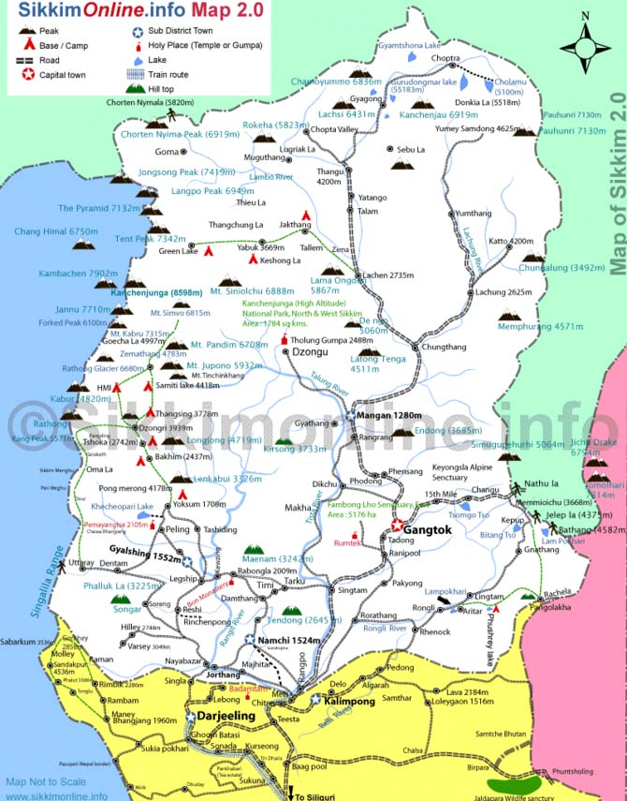

The health care infrastructure is divided into three tiers — the primary health care network, a secondary care system comprising district and sub-divisional hospitals and tertiary hospitals providing specialty and super specialty care. A Chief Medical Officer of Health (C.M.O.H.) heads each of the four districts. The responsibility of CMOH is to manage the primary health care sector and ensure the effective implementation of the various medical, health and family welfare programmes. The secondary level hospitals (sub-divisional and district hospitals) are headed by superintendents who report to the C.M.O.H. and are accountable to a hospital management committee.
Sikkim Health Service provides the health care professionals for the state-wide infrastructure, while Medical Education Service employs teachers at the training institutions.
The number and beds sanctioned in different types of healthcare setup, as published by the government of Sikkim, are in the following table. In this table, hospitals under other departments of state government include government undertaking organisations, and rural hospitals include those ones which were upgraded from block primary health centre.

S.NO. | HEALTH INSTITUTIONS | NO. OF BEDS
 |  | EAST | WEST | NORTH | SOUTH | STATE
1 | STATE REFERRAL HOSPITAL | 300 | - | - | - | 300
2 | DISTRICT HOSPITAL | 100 | 100 | 100 | 100 | 400
3 | *COMMUNITY HEALTH CENTRE | 30 | - | - | 30 | 60
4 | PRIMARY HEALTH CENTRE | 60 | 70 | 50 | 60 | 240
4 | DISTRICT TUBERCULOSIS CENTRE,NAMCHI | -- | --- | --- | 60 | 60
5 | CENTRAL REFERRAL HOSPITAL, MANIPAL TADONG (PVT.) | 500 | --- | --- | - | 500
 | TOTAL | 990 | 170 | 150 | 250 | 1560

Facilities Available at District Hospital

1. Outdoor Patient (OPD)
  - Dental Care OPD
  - ENT OPD
  - Eye OPD
  - Medical OPD
  - Orthopaedic OPD
  - Paediatric OPD
  - Surgical OPD
  - Psychiatric OPD
  - Dental OPD
  - Skin & VD OPD
  - Blood Bank
  - Specialist Services, Cardiology, Plastic Surgery, Neurology
2 . Indoor Facility for above services
  - ICU
  - CCU
  - Burn Ward
  - General Indoor Services for respective faculties
  - Anaesthetic Services
3. Investigative Procedures
  - Ultrasonography
  - CT Scan
  - X-Ray
  - Blood Bank Facility
  - Pathology Services
4. Implementation of All National Programmes
- Emergency Services
- Medico Legal
- 24 hour Ambulance service
- Post Mortem Services

- Family Welfare Services- under this Post Partum centres are located providing following services.
- Counselling
- Ante Natal Care
- Abortion & Medical Termination of Pregnancy services
- Laparoscopic Abdominal Tubectomy & Non scalpel vasectomy
- Family Welfare Services like IUD insertion , Distribution of Oral Pills & Nirodh
- Universal Immunization Programme
- Emergency Services
- Medico Legal Services
5. Ambulance Services

Facilities Available at Community Health Centre – Rural Hospitals
- Outdoor Patient (OPD)
  - Medical OPD
  - Surgical OPD
  - Paediatric OPD
  - Obstetrics & Gynaecology OPD
- Indoor Facility
- Anaesthetic Services
- Investigative Procedures
  - Ultrasonography (in selected Rural Hospitals)
  - X-Ray
  - Pathology
- Control of Epidemic, Endemic & Communicable Disease Programme
- Implementation of All National Programmes
  - Maternity & Child Health Programme
  - Family Welfare Programme
  - School Health Programme
  - Iodine Deficiency Control Programme
  - Blindness Control Programme
  - Malaria Control Programme
  - AIDS & HIV Control Programme
  - Leprosy Eradication Programme (Free distribution of MDT)
  - Tuberculosis Control Programme (Free Distribution of Medicines by DOTS Providers & Pathology Services)
  - Diarrhoeal Disease Control Programme
  - Universal Immunization Programme
- Provision of Micro Nutrients Like Vitamin A & Iron & Folic Acid
- Safe Water Supply & Basic Sanitation
- Behavioural Change Communication- Public awareness Campaign
- Collection & Reporting of Vital Statistics
- Reproductive and Child Health
  - Mother & Child Care
  - Janani Suraksha Yojna - JSY under NRHM
  - Universal Immunization Programme for Mother & Child
  - Pre, Intra & Post Dilivery Services
  - Family Welfare Services (Sterilization, Free Distribution of Oral Pills & Condoms)
- Referral Services
- Emergency Services
- Ambulance Services
- Medico Legal Services

Facilities Available at Primary Health Centre / Additional Primary Health Centre

1. General OPD
- Indoor Services (IPD)
- Control of Epidemic, Endemic & Communicable Disease Programme
- Implementation of All National Programmes
- Maternity & Child Health Programme
- Family Welfare Services
- School Health Programme
- Iodine Deficiency Control Programme
- Blindness Control Programme
- Malaria Control Programme
- AIDS & HIV Control Programme
- Leprosy Eradication Programme (Free distribution of MDT)
- Tuberculosis Control Programme with Free Distribution of Medicines
- Diarrhoea Disease Control Programme
- Universal Immunization Programme
- Provision of Micro Nutrient: Like Vitamin A & Iron & Folic Acid
- Behavioural Change Communication- Public awareness Campaign
- Safe Water Supply & Basic Sanitation
- Collection & Reporting of Vital Statistics
2. RCH (Reproductive and Child Health)
- Mother & Child Care
- Janani Suraksha Yojna - JSY under NRHM
- Universal Immunization Programme for Mother & Child
- Pre, Intra & Post Delivery Services
- Family Welfare Services (Sterilization, Free Distribution of Oral Pills & Condoms)

3. Referral Services

4. Emergency Services

CHAPTER - III

AIM & OBJECTIVES OF STUDY

There are number of hospitals and dispensaries in Public Sector Undertakings and other major service groups like Indian Army Hospitals, NHPC Hospitals, and so on. Functioning of all equipments in any healthcare facility is very critical for life saving, regular treatment and quality of care as a whole. It is well known that very often number of critical medical equipment are not functioning in public health facilities due to poor equipment management plan, lack of financial resources due to no budgetary provisions. There is a need to address this major gap in healthcare delivery infrastructure in the country.
The evaluation of project to undertake research to speculate “fiscal space” required for such an undertaking and to develop operational guidelines to establish best-practices in this domain; a study has been designed to be conducted in all Indian states in all public health facilities except the sub-centres.

Aim :
The aim of the present research study has been to find out the exact number of medical equipment in District Hospital, Community Health Centre & Primary Health Centre , its average total cost and estimated average Annual Maintenance Cost (AMC) and Annual Comprehensive Maintenance Cost (CMC) for making a financial planning and budgeting model.

Objectives :

    - Presently for management of medical equipments, since there is no provision of separate maintenance grant, recommend to the Governments for creating a separate financial head for the Equipment Maintenance Grant.

- For making provisions for separate Maintenance Grant to be collected from few District Hospitals CHCs & PHCs.

- Create a sound data bases for working out average AMC & CMC budget required for DHs, CHCs, and PHCs for yearly financial planning , budgetary allocation .

- To recommend a model plan for various states for outsourcing “management and maintenance of bio-medical technology” inclusive of operational and financial guidelines.

- Overall objective is to address the gap in technology management and maintenance in district and sub-district hospitals in the country.

- Model has been conceived on the lines of public-private partnership.

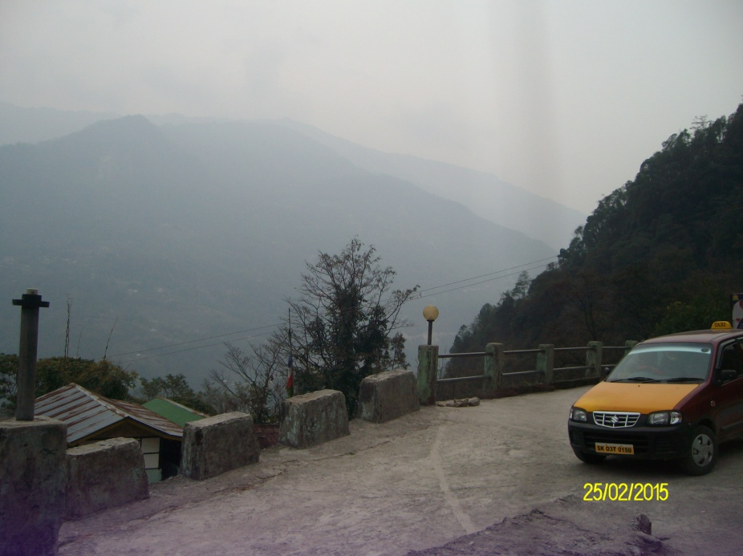

CHAPTER - IV

LITERATURE REIVEW

Health Care Organisations use technology in patient examination, diagnosing the disease and in treating patients all over the world. As the technological advancement is taking place at a rapid pace, the newer biomedical equipment are being introduced, leading to safer and better patient care. In India, the newly developed biomedical technology is adopted immediately due to globalisation and liberalisation of economy, foreign exchange rules and import of medical equipments. Medical equipments are costly, likely to break down due to sophisticated technology, continuous use and non availability of regular preventive maintenance facilities at all places. Calibration of medical equipments which is essential requirement for accurate diagnostic results for quality of patient care, is not available at Taluqa, District and State level. A very sound healthcare technology management system or biomedical equipment management has to exist in health sector in the country to ensure delivery of quality patient care without interruptions.
Medical College Hospitals, District Hospitals (DH), Community Health Centres (CHC), Primary Health Centre (PHC) are today heavily dependent upon bio medical equipment at every stage of patient care. Very large amount of capital investment is made on equipments. Nearly one third of recurring expenditure is incurred on consumable materials like drugs, dressing, reagents and disposable. At the same time various studies have shown that nearly 30-40 % of costly equipments keep lying idle due to lack of maintenance policy and necessary budget for repair and annual maintenance grant.

Medical Equipment Technology

The medical equipment technology is integral part of any health care organisation irrespective of size. Management of every District Hospital, Sub District Hospital, CHC and PHC have to pay due attention to medical equipment planning and management due to following reasons :
- Medical technology helps in improving clinical outcomes, reduce costs and improve quality of life for patients.

- It is a major component and asset of the health care industry. In one of the Asian Countries a decade earlier the sales of medical devices was 15 billion.

- Hence it is increasingly important to manage medical equipment to contain costs and improve quality and performance.

- Approximately 25%-50% of total equipments in developing countries cannot be used due to lack of funds and lack of adequate management plan and facilities. Preventive maintenance plan is more or less nonexistent.

- The same situation about non functional equipments or equipments lying idle for want of spare parts for repair

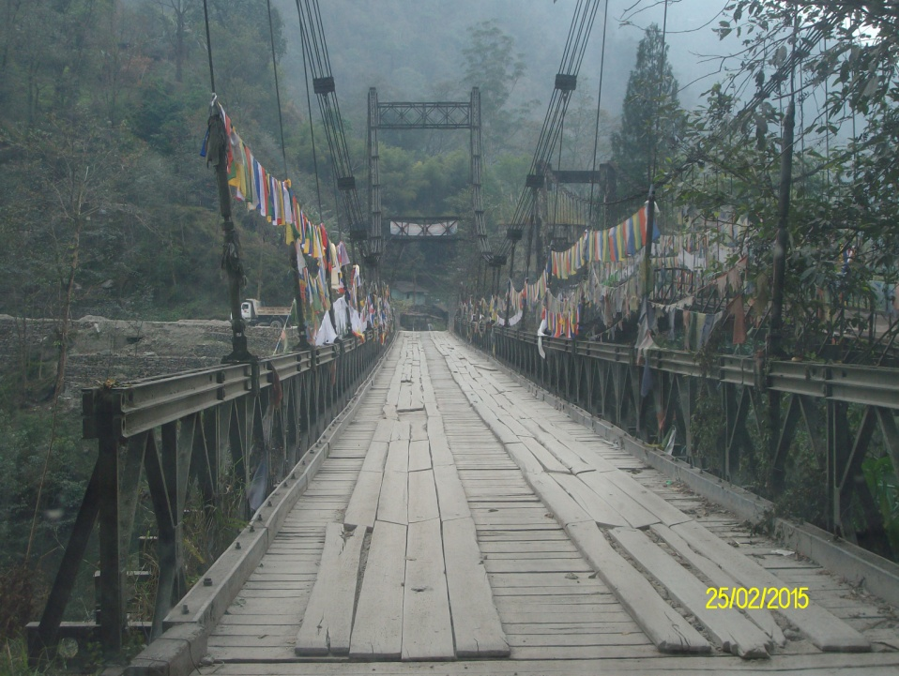

CHAPTER – V

RESEARCH PROJECT METHODOLOGY

Methodology :

- Study location: East District and North District of Sikkim

EAST DISTRICT
S.NO. | NAME OF THE INSTITUTION | BEDS | TYPE OF HOSPITAL
1 | S T N M HOSPITAL | 300 | STATE LEVEL hospital
2 | District Hospital Singtam | 100 | district hospital
3 | Rhenock | 14 | C H C
4 | Rangpo | 10 | p h c
5 | DIKCHU | 13 | p h c
6 | PACKYONG | 10 | P H C
7 | Rongli | 10 | p h c
8 | Samdong | 14 | p h c
9 | Sang | 10 | p h c
10 | Serathang | 10 | p h c (Heath post)

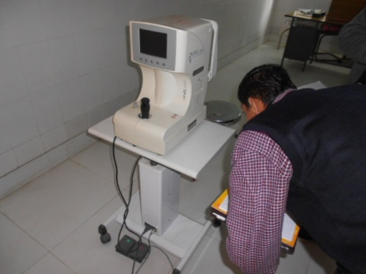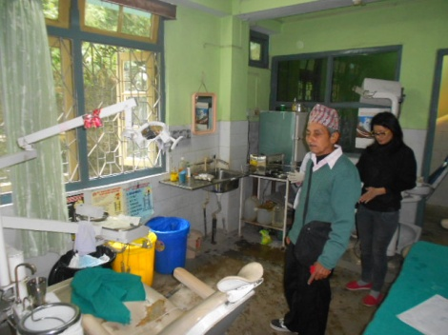

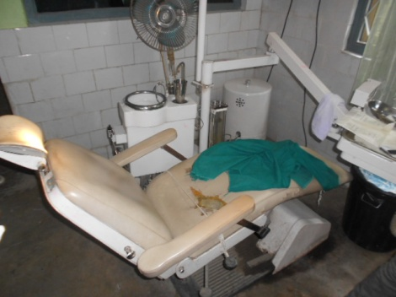

NORTH DISTRICT
S. NO. | NORTH DISTRICT | BEDS | TYPE OF HOSPITAL
1 | District Hospital Mangan | 50 | District Hospital
2 | Chungthang | 10 | p h c
3 | Phodong | 10 | p h c
4 | Passingdong | 10 | p h c
5 | MACHONG | 10 | P H C
6 | Hee-Gathang | 10 | p h c

- Study design: We did the total costs estimation of biomedical equipment taking account of its functioning status i.e. working or non-working. We have covered almost every section of the hospitals including SNCU, CCU, laboratory, X-ray department, Gynaecologist OT, emergency OT, eye OT, ortho-surgery OT, general surgery OT, S.O.T, Burn unit, CSSD, Blood bank, OPD, cabin, pathology unit, dental unit, ECG department, emergency ward, labour room, ENT department, and USG.
- Data Collection: The study conducted during last week of Februay 2015 covered a sample size of 50 hospitals across the two districts. The approval was taken from Commissioner (FW) & Mission Director (NRHM) at her Kolkata office and the respective hospital in-charges and authorities including MOs, BMO, District officer and MS. The data was collected from several sources including Stores records register, physical check-up and data collected from respective departments.
- Costing method : the costing method followed in the study includes three steps as follows:
- Line Listing of equipment in district and sub-district facilities up to the level of PHC
- Assessment of functional status of all the device/equipment
- Capturing costs required to maintain all line listed equipment
The cost estimation of the existing biomedical equipments was done on the basis of its functional status and breakdown cost.
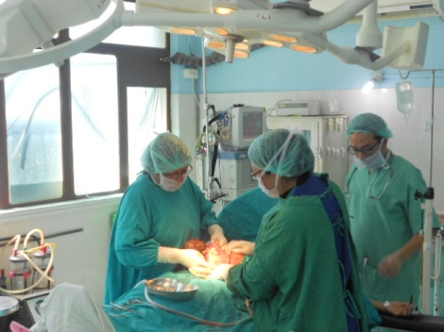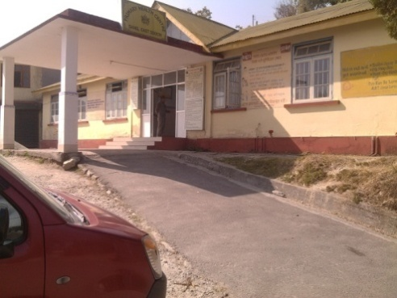

CHAPTER - VI

RESEARCH STUDY FINDINGS AND ANALYSIS

Team faced universal problem of poor record keeping of medical equipments. Date of purchase, original cost of equipment, company user manual and detailed record of breakdown and maintenance was often not available. Research Study team had to make considerable efforts and search all sources to know the cost of equipments.
Many types of medical equipment are not available in open market presently due to obselence, introduction of newer technology based on efficient software systems. Hence making maintenance programme a challenge and also costly.
The comprehensive details of medical equipments in 1 State Level Hospital, 2 District Hospitals, 1 CHC and 11 PHCs of east and North District are given in Tables on next pages as per findings of four Research Teams which visited health facilities listed in the tables.
Once PHC was found closed due to bad weather and in spite of best efforts could not be visited by Bio Medical Engineers team.
Record of date of receipt or purchase of medical equipment was not available in large number of health facilities.
There was no proper Inventory Ledger an most of the Facilities. Even there were no properly maintained RV Files for medical equipments.
Cost of each equipment was not maintained in most places. Even company manufacturer label had disappeared in many medical equipment.
Date of preventive maintenance or breakdown and breakdown maintenance was not available at most of facility sites ( DH, PHC )
Medical Officers, Specialists, Nurses and Allied Health Professionals have no idea about medical equipment maintenance, calibration, management policy and procedures.
Proper details of AMC / CMC often were not available.
There was no evidence of training programme on medical equipment management of Staff.
Lots of equipment found without proper accessories and supportive devices such as voltage stabilizers, UPS etc.
It is also observed some equipment such as Autoclaves, Oxygen gas pipeline installed with improper planning.

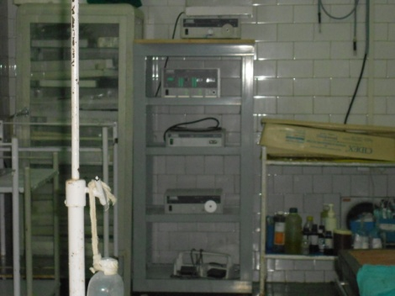

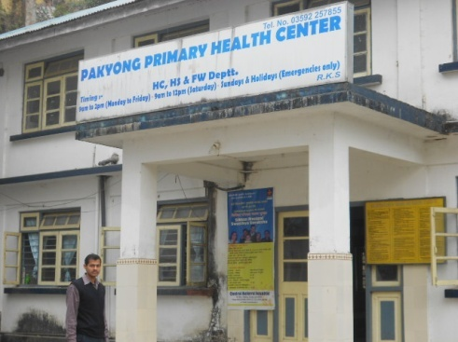

CHAPTER – VII

DISCUSSION

    - Equipment control and asset management involves the management of medical devices within a facility and may be supported by automated information systems, since all healthcare facilities in the present decade has MIS /HIS system in the health facilities.
    - Medical Equipment control begins with the receipt of a newly acquired medical equipment continues through the equipment item's entire life-cycle. Newly acquired devices require to be inspected by health facility or contracted Biomedical Equipment Technicians (BMETs) staff ( as and when it occurs) who will receive an established equipment control number / Receipt Voucher (RV ) from the facilities Equipment or Stores Manager. This control number is used to track and record maintenance actions in their database or history sheet of each medical equipment. Once an equipment control number for Receipt or Issue Voucher ( Receipt & Issue Voucher) is established, the device is inspected for safety and made ready for issue to clinical and treatment areas in the OPDs ,ICU, OTs, NICU & Wards of DH,CHC & PHCs.
    - There is a need to have a proper medical equipment management work order policy and implementation to eliminate present poor state of equipment maintenance in most of the healthcare facilities. It involves systematic, measurable, and traceable methods to all initial inspections, preventive maintenance and calibrations or repairs by generating scheduled and unscheduled work orders. Work order management may be made computer based.
    - A comprehensive work order management system can also be used as a good resource and workload management tool by Medical Superintendents or Medical Equipment Stores Managers responsible for total number of hour’s technician spent working on equipment, maximum repair amount spent for one time repair, or total amount allowed to spend repairing equipment versus replacement.
    - Post-work order quality checks involve one of two methods – full check (medical equipment audit) of all work orders or randomly selected work orders. Randomly selected work orders should place more stringent statistical controls based on the clinical criticality of the device involved. In an ideal setting, all work orders are checked. Work orders must be tracked regularly and all discrepancies must be corrected.
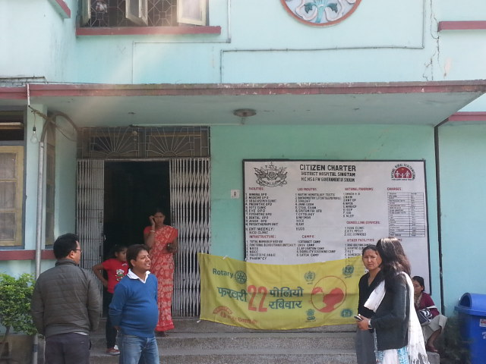

CHAPTER – VIII

RECOMMENDATIONS & CONCLUSION

  - Every healthcare facility ie DH,CHC & PHC should have policies and processes on equipment control & asset management.
  - Every Medical Officer and Stores Officer in all District Hospital, Community Hospital & Primary Health Centre needs to be given short capsule training in Medical Equipment and Inventory Management System.
  - A log book containing daily status may be maintained at micro-level to ensure proper use of the equipment, monitoring the accessories of the equipment, skill of the operator and daily maintenance of the equipment.
  - Medical Stores Officer In-Charge or a designated Medical Officer for administration of Medical Equipment should be made responsible for continuous oversight and responsibility for ensuring safe and effective equipment performance through full service maintenance throughout the year. There is a need to lay down a Government policy in each State and effective implementation of laid down policy and procedures.
  - Accurate, comprehensive on line data of medical equipment is needed to be maintained all DHs, CHCs & PHCs. It would be better to make it automated medical equipment management system.
  - There is a need to introduce a monthly Report & Return from PHC , CHC & DH to State Director Health Services giving list of serviceable, non serviceable equipment and action taken to get medical equipment repaired from the Biomedical equipment repair company under AMC/CMC.
  - There is a need to allot adequate dedicated Budget for AMC & CMC for medical equipments for all healthcare facilities in States.
  - It should be made mandatory for Senior District and State level Healthcare Executive Officers -CMOs, Director Medical & Health Services to visit the peripheral medical facilities at least twice a year, check and include status of Medical Equipments in their report.
  - Chief Medical Officers or Medical Superintendents of Medical Stores Managers who are responsible for equipment management in their organizations as per SOP of DH, CHC & PHC should also be made responsible for medical equipment technology assessment, developing policies and procedures for the medical equipment management plan, identifying trends and the need for hospital staff education, training, repair and maintenance of defective biomedical equipments.
  - The data needed to establish basic, accurate, maintainable automated records for medical equipment management would include:-
    - Nomenclature - what the device is, how, and the type of maintenance is to be performed
    - Manufacturer - Original Equipment Manufacturer (OEM).
    - Nameplate Model and serial number - The model number located on the front or behind of the equipment
    - List of accessories and supporting devices such as Voltage Stabilizers, UPS and any other device or equipment supplied with equipment for safe and optimum use of the equipment
    - Acquisition cost - total purchase price for an individual item or system. This cost includes installation, shipping, and other associated costs. These numbers are crucial for budgeting, maintenance expenditures, and depreciation accounting.
    - Condition Code - This code is required when an item is turned in and should be changed when there are major changes to the device that could affect whether or not an item should be salvaged, destroyed, or used by another Medical Treatment
    - Maintenance schedule.
    - Warranty
    - Location
    - Contractor agencies contracted for AMC/ CMC
    - Scheduled maintenance due dates
SUMMARY
    - There is a need to introduce Medical Equipment Management and Comprehensive Maintenance Policy and to be implemented in letter and spirit.
    - Short capsule courses in Medical Equipment Inventory and Maintenance Management may be introduced and made compulsory for all Medical, Nursing & Allied Health professionals in all Public Health facilities.

CHAPTER - IX

LIMITATIONS OF STUDY

1. Poor record keeping of medical equipments. However maximum possible required data was captured at DHs, CHCc and PHCs.
2. Non automation of medical equipments inventory and fragmentation of data at different wards and departments causes difficulty in compilation of statistics.
3. History Sheet of Equipment ie date of purchase, installation, state of equipment , breakdown details and such details not easily available or not available in most of facilities causes difficulty in objective assessment of serviceability and in estimating Annual Maintenance Cost or Comprehensive Maintenance Cost.
3. Poor record keeping of break downs in a month /year.
4. Data from PHC Serathang in North District could not be collected since found closed for Bad weather during visit.
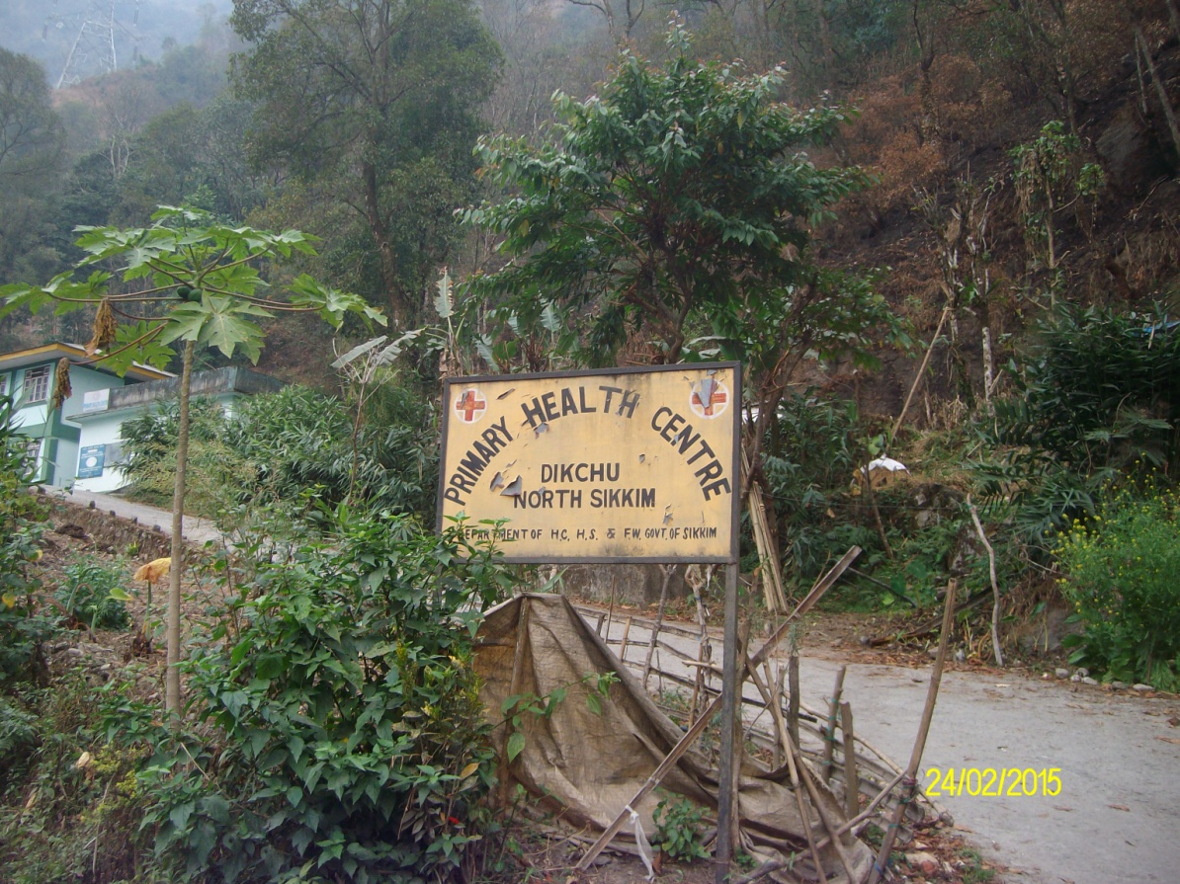

DETAILS OF CASE STUDY

NORTH DISTRICT

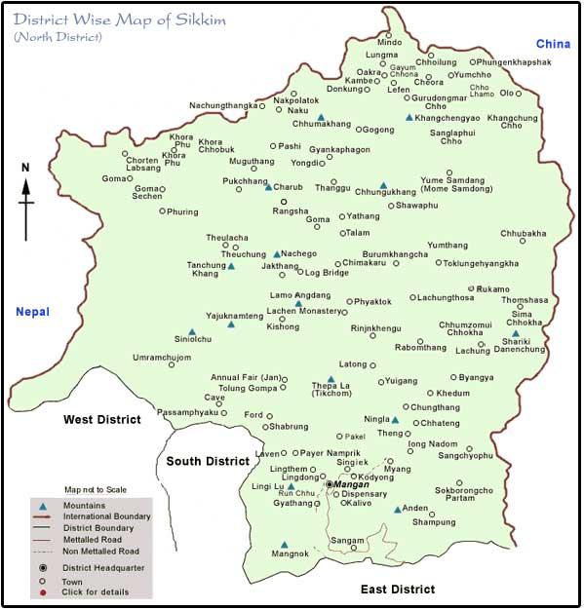

North Sikkim is a district of the Indian state of Sikkim. Its district headquarters is Mangan. It is the seventh least populous district in the country (out of 640).
Headquarters : Mangan
Total Area : 4,226 km² (1,632 sq mi)
Elevation : 610 m (2,000 ft)
Population (2011) : 43,354
Density : 10/km² (27/sq mi)

According to the 2011 census North Sikkim district has a population of 43,354, roughly equal to the nation of Liechtenstein. This gives it a ranking of 634th in India (out of a total of 640). The district has a population density of 10 inhabitants per square kilometre (26/sq mi) . Its population growth rate over the decade 2001-2011 was 5.66%. North Sikkim has a sex ratio of 769females for every 1000 males, and a literacy rate of 77.39%.
The people are mainly of Nepali descent. Other ethnic groups include the Lepcha and Bhutia communities.
Nepali is the most widely spoken language in the district. It also has one of the lowest populated regions of the state.

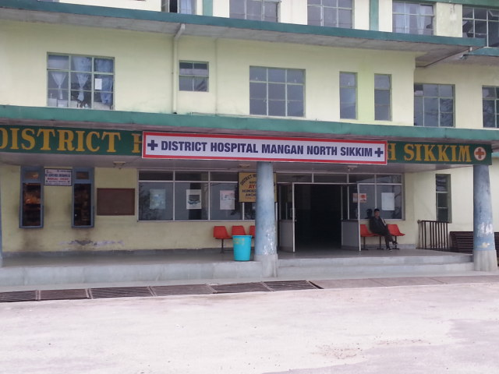

Biomedical Equipment Maintenance Model ( A Joint Study by NHSRC and Mass Biomedicals Pvt. Ltd., New Delhi)
Location :-D.H.Mangan |  |  |  | Name of the Head & Ph No: - Dr.D.S.Kerongi, Mob. No.-09434136948
Equipment ID | Department | Equipment Description | Model Number | Serial Number | Installation Date | Functional Status |  | Qty. | Approx. Cost of Each Equipment | Total Cost Of Equipment
 |  |  |  |  |  | W | NW
# | PATHOLOGY | Domestic Refrigerator | Godrej-200Ltr | * | * | 1 |  | 1 | 18000.00 | 18000.00
# |  |  | Godrej-100Ltr | * | * | 1 |  | 1 | 10000.00 | 10000.00
# |  | Needle Destroyer | Hospit Time | * | * | 1 |  | 1 | 1200.00 | 1200.00
# |  | Serological Water Bath | Yarco | * | * | 1 |  | 1 | 45000.00 | 45000.00
# |  | Hot Air Oven | Yarco | * | * | 1 |  | 1 | 25000.00 | 25000.00
# |  | Centrifuge | Bimicm | * | * | 1 |  | 1 | 6500.00 | 6500.00
# |  | Microscope (Binocular) | Labomed,Vission-2000 | 88193 | * | 1 |  | 1 | 15500.00 | 15500.00
# |  | Semi Auto Analyzer | Transasia-Chsm-5Plus | 100257 | * | 1 |  | 1 | 200000.00 | 200000.00
# |  | Analyzer | KX-21 | B5606 | Dec-09 | 1 |  | 1 | 200000.00 | 200000.00
# |  | Centrifuge | Remi-R-86 | DDLC-4377 | Apr-10 | 1 |  | 1 | 6500.00 | 6500.00
# |  | Electrolyte Analyzer | Easy Type Plus | 34582BNKE | * | 1 |  | 1 | 200000.00 | 200000.00
# |  | Analyzer | Pransasia,8M200 | EM-200-800121 | * |  | 1 | 1 | 200000.00 | 200000.00
# |  | Domestic Refrigerator | Godrej-200Ltr | * | * | 1 |  | 1 | 18000.00 | 18000.00
# |  | Hot Air Oven | Yarco-YSI-431 | * | * | 1 |  | 1 | 25000.00 | 25000.00
# | X-RAY & EYE | X-Ray Machine (10MA) | ME-0610M | * | * | 1 |  | 1 | 450000.00 | 450000.00
# |  | X-Ray Machine (300MA) | ME-3010 | * | * | 1 |  | 1 | 450000.00 | 450000.00
# | DENTAL | Dental Chair | Corident Model-iv | * | * | 2 |  | 2 | 150000.00 | 300000.00
# |  | Sterilizer (Medium) | * | * | * | 1 |  | 1 | 4500.00 | 4500.00
# |  | Needle Destroyer | * | * | * | 1 |  | 1 | 1200.00 | 1200.00
# |  | X-Ray Machine | Corident,BlueX | 2305BR8949 | * | 1 |  | 1 | 450000.00 | 450000.00
# | FAMILY WELFAIR | Baby Weighing Machine | Misaki | * | * | 1 |  | 1 | 1500.00 | 1500.00
# |  | Needle Destroyer | Medigold | * | * | 1 | 1 | 2 | 1200.00 | 2400.00
# |  | Adult Weighing Machine | Crown | * | * | 1 | 4 | 5 | 3000.00 | 15000.00
# |  | Hot Air Oven | Yarco-YSI-431 | D1H2801 | * | 1 |  | 1 | 25000.00 | 25000.00
# |  | Sterilizer (Medium) | * | * | * |  | 1 | 1 | 4500.00 | 4500.00
# |  | Spot Light | * | * | * |  | 1 | 1 | 6500.00 | 6500.00
# | PHYSIOTHERAPY | Electric Stimulator | Dinesh | * | * |  | 1 | 1 | 4500.00 | 4500.00
# |  | Ultrasound Therapy | * | * | * |  | 1 | 1 | 350000.00 | 350000.00
# |  | Traction Machine | * | * | * |  | 1 | 1 | 38000.00 | 38000.00
# |  | Manual Lumber Traction | Weighing Bag Faulty | * | * |  | 1 | 1 | 18000.00 | 18000.00
# |  | Manual Cervical Traction | * | * | * | 1 |  | 1 | 18000.00 | 18000.00
# | PEDIATRIC | Examination Bed | * | * | * | 1 |  | 1 | 12000.00 | 12000.00
# |  | Baby Weighing Machine | Moh & FW | * | * | 1 |  | 1 | 1500.00 | 1500.00
# |  | Adult Weighing Machine | Health O Meter | * | * | 1 |  | 1 | 1500.00 | 1500.00
# | LABOUR ROOM | Hot Air Oven | Yarco,YSI-438 | 0181985 | * | 1 |  | 1 | 25000.00 | 25000.00
# |  | Needle Destroyer | Ramtech | * | * | 1 |  | 1 | 1200.00 | 1200.00
# |  | Labour Table | Mannual | * | * | 4 |  | 4 | 14000.00 | 56000.00
# |  | Suction Machine | Surgi-Vac | C-204-005 | * | 1 |  | 1 | 6500.00 | 6500.00
# |  |  | * | C-197-014 | * | 1 |  | 1 | 6500.00 | 6500.00
# |  | Examination Light | Cognate | * | * | 1 |  | 1 | 8000.00 | 8000.00

# | LABOUR ROOM |  | Warmer |  |  |  | Meditrin | * | * |  | 1 |  | 1 | 38000.00 | 38000.00
# |  |  | Suction Machine (Foot) |  |  |  | * | * | * |  | 1 |  | 1 | 4500.00 | 4500.00
# |  |  | Baby Weighing Machine(Dig.) |  |  |  | Cworn | * | * |  |  | 1 | 1 | 3000.00 | 3000.00
# |  |  | Baby Weighing Machine(Anal.) |  |  |  | Masaki | * | * |  | 1 |  | 1 | 2500.00 | 2500.00
# |  |  | Sterilizer (Medium) |  |  |  | * | * | * |  |  | 1 | 1 | 6500.00 | 6500.00
# | MINOR O.T |  | Sterilizer (Medium) |  |  |  | * | * | * |  | 1 |  | 1 | 6500.00 | 6500.00
# |  |  | Examination Light |  |  |  | Cognate | * | * |  | 1 |  | 1 | 8000.00 | 8000.00
# |  |  | Domestic Refrigerator |  |  |  | LG-165Ltr. | * | * |  | 1 |  | 1 | 15000.00 | 15000.00
# |  |  | O.T.Table |  |  |  | Manual | * | * |  | 1 |  | 1 | 45000.00 | 45000.00
# | GYNAE CLINIC |  | Labour Table |  |  |  | Manual | * | * |  | 1 |  | 1 | 14000.00 | 14000.00
# |  |  | Sterilizer |  |  |  | * | * | * |  | 1 |  | 1 | 6500.00 | 6500.00
# |  |  | Spot Light |  |  |  | * | * | * |  | 2 |  | 2 | 6500.00 | 13000.00
# | INDOOR PATIENT |  | Suction Machine |  |  |  | Surgi-Vac | C-162-016 | * |  |  | 1 | 1 | 6500.00 | 6500.00
# |  |  |  |  |  |  |  | C-204-004 | * |  | 1 |  | 1 | 6500.00 | 6500.00
# |  |  | Adult Weighing Machine |  |  |  | Crown | * | * |  |  | 1 | 1 | 3000.00 | 3000.00
# |  |  | Nebulizer (Single Port) |  |  |  | Medigold | * | * |  | 2 |  | 2 | 4500.00 | 9000.00
# |  |  | Pulse Oxymeter |  |  |  | BPL-Elco,PO5885 | Cmm238535 | * |  | 1 |  | 1 | 55000.00 | 55000.00
# |  |  | Laryngoscope |  |  |  | * | * | * |  | 2 |  | 2 | 45000.00 | 90000.00
# |  |  | B.P.Apparatus |  |  |  | Life Line | * | * |  | 1 |  | 1 | 650.00 | 650.00
# |  |  | Blood Infussion Warmer |  |  |  | Flotherm,OW-618 | 61301054 | * |  | 1 |  | 1 | 16500.00 | 16500.00
# |  |  | Needle Destroyer |  |  |  | Medigold | * | * |  | 1 | 1 | 2 | 1200.00 | 2400.00
# |  |  | Intensive Care Warmer Cab. |  |  |  | Life Line | * | * |  | 2 |  | 2 | 38000.00 | 76000.00
# |  |  | Phottherapy |  |  |  | Meditrin | * | * |  | 1 |  | 1 | 16000.00 | 16000.00
# |  |  | Wighing Machine (Digital) |  |  |  | Cworn | * | * |  | 1 |  | 1 | 3000.00 | 3000.00
# |  |  | Intensive Care Warmer Cab. |  |  |  | Meditrin | * | * |  | 2 |  | 2 | 38000.00 | 76000.00
# |  |  | Suction Machine |  |  |  | Anand | 31M4278 | * |  | 1 |  | 1 | 6500.00 | 6500.00
# |  |  | Syringe Infussion Pump |  |  |  | Aspire | PTPL/A3Par | * |  | 1 |  | 1 | 52000.00 | 52000.00
# |  |  | Nebulizer (Single Port) |  |  |  | Life Line | * | * |  | 1 | 5 | 6 | 4500.00 | 27000.00
# |  |  | Infussion Pump |  |  |  | Akas Infu Max | IX07140733 | * |  | 1 |  | 1 | 52000.00 | 52000.00
# |  |  | Pulse Oxymeter |  |  |  | BPL-Clen 5 Plus | DYMG412890 | * |  | 1 |  | 1 | 55000.00 | 55000.00
# |  |  | Oxygen Concentrator |  |  |  | BPL-OG4305 | EYTA4K1820 | * |  | 1 |  | 1 | 45000.00 | 45000.00
# |  |  | Ambu Bag |  |  |  | * | * | * |  | 1 |  | 1 | 1100.00 | 1100.00
# |  |  | Autoclave (Cooker Type) |  |  |  | * | * | * |  | 1 |  | 1 | 25000.00 | 25000.00
# |  |  | Ambu Bag (Pediatric) |  |  |  | * | * | * |  | 2 |  | 2 | 1100.00 | 2200.00
# |  |  | Stretcher |  |  |  | * | * | * |  | 3 |  | 3 | 8000.00 | 24000.00
# | O.T |  | Ceiling O.T Light |  |  |  | Omex | * | * |  | 1 |  | 1 | 26000.00 | 26000.00
# |  |  | O.T.Table (Hydrolic) |  |  |  | Cognate | * | * |  | 2 |  | 2 | 70000.00 | 140000.00
# |  |  | Anaesthesia Machine |  |  |  | Major Plus | * | * |  | 1 |  | 1 | 45000.00 | 45000.00
# |  |  |  |  |  |  | Dragor,Fablus | ARXE-001 | * |  | 1 |  | 1 | 45000.00 | 45000.00
# |  |  |  |  |  |  | Chattergec Surgical | * | * |  | 1 |  | 1 | 45000.00 | 45000.00
# |  |  | Microscope (Surgical) |  |  |  | HS International,Wodel | 681 | * |  | 1 |  | 1 | 15500.00 | 15500.00
# |  | O.T |  | Cautery Machine |  | Digital-400 |  | EO351289 |  | * | 1 |  | 1 | 55000.00 | 55000.00
# |  |  |  | Suction Machine |  | Surgi-Vac |  | C-205-010 |  | * | 1 |  | 1 | 6500.00 | 6500.00
# |  |  |  | O.T.Table (Hydrolic) |  | * |  | * |  | * | 1 |  | 1 | 70000.00 | 70000.00
# |  | STORE |  | Autoclave (Horizontal) |  | Yarco |  | * |  | * | 1 |  | 1 | 55000.00 | 55000.00
# |  |  |  | E.C.G Machine |  | BPL |  | ACMA393371 |  | * |  | 1 | 1 | 52000.00 | 52000.00
# |  |  |  | E.C.G Machine |  | * |  | JIF-24691 |  | * |  | 1 | 1 | 52000.00 | 52000.00
# |  |  |  | Ambu Bag |  | * |  | * |  | * | 9 |  | 9 | 1100.00 | 9900.00
# |  |  |  | Ultrasound |  | Siemens |  | * |  | * |  | 1 | 1 | 350000.00 | 350000.00
# |  |  |  | E.C.G Machine |  | BPL |  | * |  | * | 1 | 2 | 3 | 52000.00 | 156000.00
# |  |  |  | Suction Machine |  | Surgi-Vac |  | C-205-013 |  | * | 1 |  | 1 | 6500.00 | 6500.00
# |  | ULTRASOUND & E.C.G |  | E.C.G Machine |  | BPL,Cardiant-108T-DIGI |  | CGMJ1J1-4727 |  | * | 1 |  | 1 | 52000.00 | 52000.00
# |  |  |  | Ultrasound Machine |  | Siemens,MC-2H6J3-M |  | 65644664 |  | Oct-11 |  | 1 | 1 | 450000.00 | 450000.00
Note
 |  |  |  |  |  |  |  |  |  |  |  |  | Total No. Of Equipment: 127
# |  | Not Created / Not Found |  |  |  |  |  | No. Of Bed |  | 100 |  |  | Total Equipment Cost: ` 56,72,250 .00
* |  | Not Available |  |  |  |  |  | No. Of Staff |  | 121 |  |  | Total CMC Value: ` 3,97,057.00

Biomedical Equipment Maintenance Model ( A Joint Study by NHSRC and Mass Biomedicals Pvt. Ltd., New Delhi)
Location:- P.H.C Phodong |  |  |  |  | Name of the Head & Ph No.:- Dr. Dichin Bhutia, Mob. No:- 09609017594
Equipment ID | Department | Equipment Description | Make/Model No. | Serial Number | Installation Date | Functional Status |  | Qty. | Approx. Cost Of Each Equipment | Total Cost Of Equipment
 |  |  |  |  |  | W | NW
# | # | Needle Destroyer | Hospi + Time | * | * | 2 |  | 2 | 1,200.00 | 2,400.00
# | # | Adult Weighing M/C | Crown | * | * | 2 |  | 2 | 3,000.00 | 6,000.00
# | # | Domestic Refrigerator | Electrolux 1652 | * | * | 1 |  | 1 | 18,000.00 | 18,000.00
# | # | B. P. Apparatus | Anriod | * | * | 1 |  | 1 | 650.00 | 650.00
# | # | Sterilizer (Medium) | * | * | * | 1 | 1 | 2 | 6,500.00 | 13,000.00
# | # | Autoclave (Medium) | * | * | * |  | 2 | 2 | 26,500.00 | 53,000.00
# | # | O.T. Table Hydraulic | Cognate, | * | * |  | 1 | 1 | 70,000.00 | 70,000.00
# | # | Ceiling OT Light (7 Bulb) | Cognate, m/n-CLH - 7 | * | * |  | 1 | 1 | 70,000.00 | 70,000.00
# | # | Suction m/c | Surgi- Vac, M/N - Type - 1 | * | * |  | 1 | 1 | 6,500.00 | 6,500.00
# | # | Radiant Warmer | Meditrin,( Tender care) | * | * | 1 |  | 1 | 85,000.00 | 85,000.00
# | # | Intensive Care Warmer with basinet | Indian (5 x) | * | * | 1 |  | 1 | 100,000.00 | 100,000.00
# | # | Baby Weighing m/c | Crown | * | * | 1 |  | 1 | 3,000.00 | 3,000.00
# | # | Labor Table | Indian | * | * | 1 |  | 1 | 14,000.00 | 14,000.00
# | # | Spot Light | Indian | * | * | 1 |  | 1 | 6,500.00 | 6,500.00
# | # | Stethoscope | * | * | * | 1 |  | 1 | 650.00 | 650.00
# | # | Stretcher | Indian | * | * | 2 |  | 2 | 4,200.00 | 8,400.00
# | # | Single Port Nebulizer | Flame Nouva | 175287/64 | * | 1 |  | 1 | 8,500.00 | 8,500.00
# | # | Wheel Chair | Indian | * | * | 2 |  | 2 | 4,500.00 | 9,000.00
NOTE
 |  |  |  |  |  |  | Total No.Of Equipment |  |  | 24
# | Not Created / Not Found |  |  | No. of Bed | 10 |  | Total Equipment Cost |  |  | 474,600.00
* | Not Available |  |  | No. of Staff | 24 |  | Total CMC Cost |  |  | 33,222.00

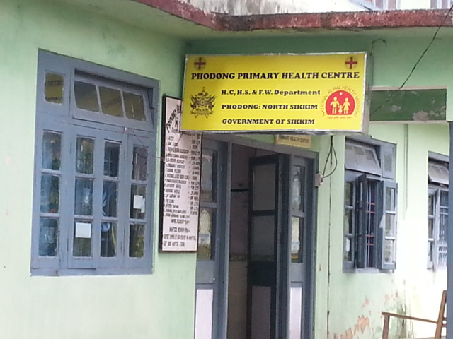
Biomedical Equipment Maintenance Model ( A Joint Study by NHSRC and Mass Biomedicals Pvt. Ltd., New Delhi)
Location :- P.H.C Passing Dong |  |  |  |  | Name of the Head & Ph No :- Dr. H.K.Rai, Mob. No.- 8158881199
Equipment ID | Department | Equipment Description | Model Number | Serial Number | Installation Date | Functional Status |  | Qty. | Approx. Cost of Each Equipment | Total Cost Of Equipment
 |  |  |  |  |  | W | NW
# | D.ROOM | Needle Destroyer | Medigold | * | * | 1 |  | 1 | 1200.00 | 1200.00
# | LABOUR ROOM | Baby Warmer | Meditrin | * | * | 1 |  | 1 | 18000.00 | 18000.00
# |  | Phototherapy | Meditrin | * | * | 1 |  | 1 | 16000.00 | 16000.00
# |  | Ambo Bag (Adult) | * | * | * | 2 |  | 2 | 1100.00 | 2200.00
# |  | Suction Machine | Surgic-Voc | C-204-018 | * | 1 |  | 1 | 6500.00 | 6500.00
# |  | Labour Table | * | * | * | 1 |  | 1 | 14000.00 | 14000.00
# |  | Adult Weighing M/C | * | * | * | 1 |  | 1 | 2500.00 | 2500.00
# |  | Baby Weighing M/C | Misaik | * | * | 1 |  | 1 | 3000.00 | 3000.00
# | STORE | Autoclave (Verticle) | * | * | * |  | 1 | 1 | 65000.00 | 65000.00
# |  | Sterilizer (Medium) | * | * | * |  | 1 | 1 | 8500.00 | 8500.00
# |  | Sterilizer (Small) | * | * | * |  | 3 | 3 | 6500.00 | 19500.00
# |  | Needle Destroyer | * | * | * |  | 1 | 1 | 1200.00 | 1200.00
# |  | Autoclave (Verticle) | Sareen Surgical Life-X | * | * | 1 |  | 1 | 65000.00 | 65000.00
# |  | Suction Machine | Surgic-Voc | C231-019 | * | 1 |  | 1 | 6500.00 | 6500.00
# |  |  |  | C-234-017 | * | 1 |  | 1 | 6500.00 | 6500.00
# |  |  |  | C-292-002 | * | 1 |  | 1 | 6500.00 | 6500.00
# |  | Needle Destroyer | Ramtex | * | * | 1 |  | 1 | 1200.00 | 1200.00
# |  | B.P.Apparatur | * | * | * | 1 | 1 | 2 | 650.00 | 1300.00
# |  | Ceilling O.T.Light | * | * | * |  | 1 | 1 | 26000.00 | 26000.00
# |  | Sterilizer | * | * | * |  | 8 | 8 | 6500.00 | 52000.00
Note
 |  |  |  |  |  |  | Total No. Of Equipment |  |  | 31
# | Not Created / Not Found |  |  | No. Of Bed | 10 |  | Total Equipment Cost |  |  | 322600.00
* | Not Available |  |  | No. Of Staff | 18 |  | Total CMC Value |  |  | 22582.00

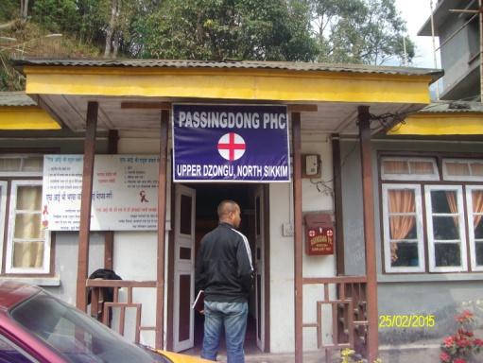
Biomedical Equipment Maintenance Model ( A Joint Study by NHSRC and Mass Biomedicals Pvt. Ltd., New Delhi)
Location :- P.H.C Heegyathan |  |  |  | Name of the Head & Ph No :- Dr.Prabhat Mukaton, Mob. No.- 09547091790
Equipment ID | Department | Equipment Description | Model Number | Serial Number | Installation Date | Functional Status |  | Qty. | Approx. Cost of Each Equipment | Total Cost Of Equipment
 |  |  |  |  |  | W | NW
# | O.T | Ceilling O.T Light | Cognate | * | * |  | 1 | 1 | 26000.00 | 26000.00
# |  | Hydrolic O.T Table | Omax | * | * |  | 1 | 1 | 70000.00 | 70000.00
# |  | Sterilizer | * | * | * |  | 1 | 1 | 6500.00 | 6500.00
# |  | Needle Destroyer | Hospit Time | * | * | 1 | 1 | 2 | 1200.00 | 2400.00
# | PATH LAB | Bio Chemist Analyzer | Erba,Chemp-5Plus | 100303 | * | 1 |  | 1 | 200000.00 | 200000.00
# |  | Calorimeter (Digital) | Systronic,112 | 9284 | * | 1 |  | 1 | 1400.00 | 1400.00
# |  | Centrifuge | Remi,C-852 | CDLC-3320 | * | 1 |  | 1 | 6500.00 | 6500.00
# |  | Water Bath | Yarco | * | * | 1 |  | 1 | 4500.00 | 4500.00
# |  | Microscope | Olympus,CH-20I | 10D-022 | * | 1 |  | 1 | 15500.00 | 15500.00
# |  | Oven | Yarco | * | * | 1 |  | 1 | 25000.00 | 25000.00
# |  | Refrigerator | Godrej,GDN-185D | 100601961 | * | 1 |  | 1 | 15000.00 | 15000.00
# | LABOUR ROOM | Baby Warmer | Meditrin | * | * | 1 |  | 1 | 18000.00 | 18000.00
# |  | Phototherapy | Meditrin | * | * | 1 |  | 1 | 16000.00 | 16000.00
# |  | Examination Light | * | * | * | 1 |  | 1 | 8000.00 | 8000.00
# |  | Labour Table | * | * | * | 1 |  | 1 | 14000.00 | 14000.00
# |  | Suction Machine | Foot Type | * | * | 1 |  | 1 | 6500.00 | 6500.00
# |  | Ambo Bag | * | * | * | 1 |  | 1 | 1100.00 | 1100.00
# |  | Baby Weighing M/C | Crown | * | * | 1 |  | 1 | 3000.00 | 3000.00
# |  | Autocalve (Verticle) | Yarco,YSL-402 | 11H-2286 | * |  | 1 | 1 | 2500.00 | 2500.00
Note
 |  |  |  |  |  |  | Total No. Of Equipment |  |  | 20
# | Not Created / Not Found |  |  | No. Of Bed's | 10 |  | Total Equipment Cost |  |  | 441900.00
* | Not Available |  |  | No. Of Staff | 18 |  | Total CMC Value |  |  | 30933.00

Biomedical Equipment Maintenance Model ( A Joint Study by NHSRC and Mass Biomedicals Pvt. Ltd., New Delhi.)
Location:- P.H.C Machong |  |  |  |  | Name of the Head & Ph No.:- Dr. Karma Gurmyth Bhutia, Mob.:- 08592044420
Equipment ID | Department | Equipment Description | Make/Model No. | Serial Number | Installation Date | Functional Status |  | Qty. | Approx. Cost Of Each Equipment | Total Cost Of Equipment
 |  |  |  |  |  | W | NW
# | Labor Room | Baby Weighing m/c | Misaki | * | * | 1 |  | 1 | 3,000.00 | 3,000.00
# |  | Intensive Care Warmer | Meditrin | * | * | 1 |  | 1 | 100,000.00 | 100,000.00
# |  | Radiant Warmer | Meditrin (Tender Care) | * | * | 1 |  | 1 | 85,000.00 | 85,000.00
# |  | Spot Light | * | * | * | 1 |  | 1 | 6,500.00 | 6,500.00
# |  | Sterilizer (Small) | * | * | * | 1 |  | 1 | 6,500.00 | 6,500.00
# |  | Labor Table | Indian | * | * | 1 |  | 1 | 14,000.00 | 14,000.00
# |  | Needle Destroyer | Hospi + Time | * | * |  | 1 | 1 | 1,200.00 | 1,200.00
# |  | Hub Cutter | * | * | * |  | 1 | 1 | 1,500.00 | 1,500.00
# | Dressing | Sterilizer (Medium) | Surgi- Vac, M/N - Type - 1 | * | * |  | 1 | 1 | 6,500.00 | 6,500.00
# |  | Hot Air Oven | Yorco | * | * | 1 | 1 | 2 | 4,500.00 | 9,000.00
# |  | Examination Light | Cognate | * | * | 1 |  | 1 | 8,000.00 | 8,000.00
# | Store | Single Port Nebulizer | Ormon, M/n - NE - C28 | 20100702464UF | * | 1 |  | 1 | 8,500.00 | 8,500.00
# |  | Autoclave (V) | Indian | * | * | 1 | 1 | 2 | 65,000.00 | 130,000.00
# |  | Suction Machine | Surgi- Vac, | * | * | 2 |  | 2 | 6,500.00 | 13,000.00
# |  | O. T. Table | Cognate | * | * | 1 |  | 1 | 45,000.00 | 45,000.00
# |  | Examination Light | Cognate | * | * | 1 |  | 1 | 8,000.00 | 8,000.00
# |  | Ceiling OT Light (7+4Bulb) | Cognate | * | * | 1 |  | 1 | 70,000.00 | 70,000.00
# |  | B.P.Apparatus (Hg) | Life + Line | * | * | 1 |  | 1 | 650.00 | 650.00
# |  | Adult Weighing machine | Health O Meter | * | * | 1 |  | 1 | 3,000.00 | 3,000.00
NOTE
 |  |  |  |  |  |  | Total No.Of Equipment |  |  | 22
# | Not Created / Not Found |  |  | No. of Bed | 10 |  | Total Equipment Cost |  |  | 519,350.00
* | Not Available |  |  | No. of Staff | 20 |  | Total CMC Cost |  |  | 36,354.50

Biomedical Equipment Maintenance Model ( A Joint Study by NHSRC and Mass Biomedicals Pvt. Ltd. New Delhi)
Location :- P.H.C Chungthang |  |  |  |  | Name of the Head & Ph No :- Dr. Dupjorlepecher, Mob. No:- ( 09647878310)
Equipment ID | Department | Equipment Description | Model Number | Serial Number | Installation Date | Functional Status |  | Qty. | Approx. Cost of Each Equipment | Total Cost Of Equipment
 |  |  |  |  |  | W | NW
# | PATHOLOGY | Biochemistry Analyzer | Erba Chem 5 plus | 100273 | * | 1 |  | 1 | 225000.00 | 225000.00
# |  | Oven | Yorco, ISI - 431` | 10C4578 | * | 1 |  | 1 | 25000.00 | 25000.00
# |  | Centrifuge | Remi , C-885 | CDLC-3321 | * | 1 |  | 1 | 6500.00 | 6500.00
# |  | Needle Destroyer | Ramfec | * | * | 1 |  | 1 | 1200.00 | 1200.00
# |  | Water Bath | Yorco | * | * | 1 |  | 1 | 4500.00 | 4500.00
# |  | Refrigerator | Godrej,185 L | * | * | 1 |  | 1 | 13000.00 | 13000.00
# | X-Ray | X-Ray Machine | M.E. X-ray,ME-0610 | 98 | * | 1 |  | 1 | 450000.00 | 450000.00
# | DRESSING ROOM | Sterilizer | * | * | * | 1 |  | 1 | 6500.00 | 6500.00
# |  | Suction Machine | Anand | 3E4523 | * | 1 |  | 1 | 6500.00 | 6500.00
# | DENTAL CHAIR | Dental Chair | * | * | * |  | 1 | 1 | 150000.00 | 150000.00
# | O.T.ROOM | Vertical Autoclave | Life - X | * | * |  | 1 | 1 | 65000.00 | 65000.00
# |  | Ceiling O.T. Light (7 bulb) | Cognate | * | * |  | 1 | 1 | 70000.00 | 70000.00
# |  | O.T. Table | * | * | * |  | 1 | 1 | 45000.00 | 45000.00
# |  | Incubator | Yorco | * | * |  | 2 | 2 | 8500.00 | 17000.00
# |  | Suction Machine | Surgi-Vac | C1212-013, | * | 3 |  | 3 | 6500.00 | 19500.00
# |  | Baby weighing machine | Dial Type | * | * | 2 | 4 | 6 | 3000.00 | 18000.00
# | LABOUR ROOM | Baby Warmer | Meditrin | * | * | 1 |  | 1 | 18000.00 | 18000.00
# |  | Phototherapy |  | * | * | 1 |  | 1 | 16000.00 | 16000.00
# |  | Suction Machine | Surgi- Vac | C-176-010 | * | 1 |  | 1 | 6500.00 | 6500.00
# |  | Baby weighing machine | * | * | * | 2 |  | 2 | 3000.00 | 6000.00
# |  | B.P. Apparatus | * | * | * | 1 | 4 | 5 | 650.00 | 3250.00
Note
 |  |  |  |  |  |  | Total No. Of Equipment |  |  | 34
# | Not Created / Not Found |  |  | No. of Bed | 10 |  | Total Equipment Cost |  |  | 1172450.00
* | Not Available |  |  | No. of Staff | 22 |  | Total CMC Value |  |  | 82071.50

DETAILED STUDY OF MEDICAL EQUIPMENT IN THE DISTRICT OF North District of Sikkim
SI NO. | Name of the Institution | No. of  sanctioned Beds | Type of Hospital | Total Equipment | Total Cost of Equipment ` |  | No. of  Working Equip. | No. of not Working Equip. | % of D'fuct Equip. | AMCCahrges @7% of Asset value `
1 | D.H.Mangan | 50 | DH | 127 | 5,672,250.00 |  | 99 | 28 | 22.05 | 397,057.50
2 | P.H.C Hegyathan | 10 | P.H.C | 20 | 441,900.00 |  | 15 | 5 | 25.00 | 30,933.00
3 | P.H.C PASSING DONG | 10 | P.H.C | 31 | 322,600.00 |  | 15 | 16 | 51.61 | 22,582.00
4 | P.H.C Machong | 10 | P.H.C | 22 | 519,350.00 |  | 17 | 5 | 22.73 | 36,354.50
5 | P.H.C Phodong | 10 | P.H.C | 24 | 474,600.00 |  | 18 | 6 | 25.00 | 33,222.00
6 | P.H.C Chungthang | 10 | P.H.C | 34 | 1,172,450.00 |  | 20 | 14 | 41.18 | 82,071.50
Percentage of D’sfunc. equipment 22.05 % to 51.61%
Summary of Biomedical Equipment Inventory Survey in North District of Sikkim
Name of facility with Highest Dysfunctional Rate : P. H. C Passingdong
Highest Dysfunctional Rate : 51.61%
Name of facility with Lowest Dysfunctional Rate : D.H. Mangan
Lowest Dysfunctional Rate : 22.05%
Average Dysfunctional Rate : 31.26%
Average CMC Cost @ 7% of the cost of Equipment
Total No. of Equipment : 258
CMC Cost for the whole District: 6,02,220.00

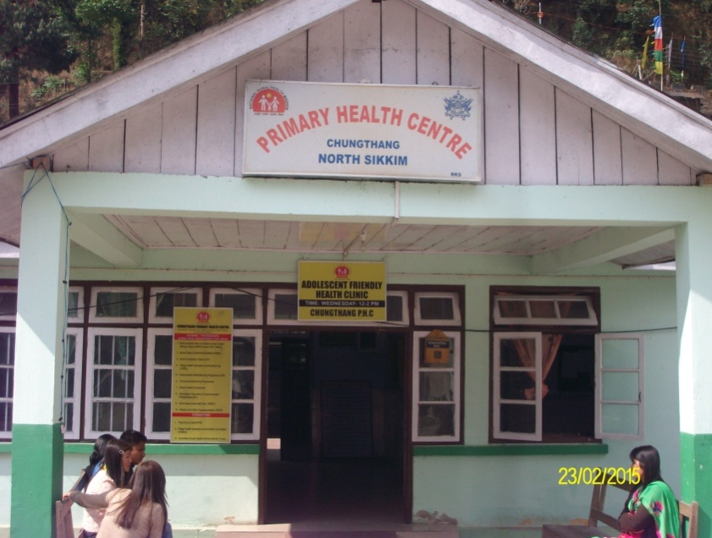
EAST DISTRICT

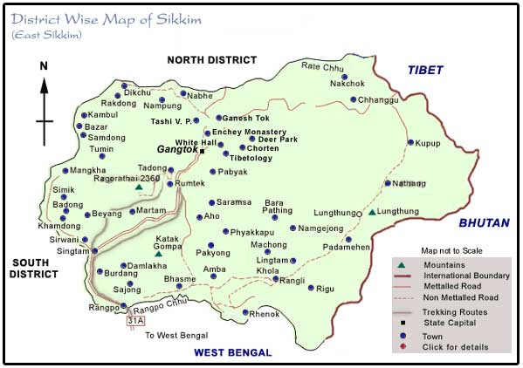
East Sikkim is one of the four administrative districts of the Indian state of Sikkim. Geographically, East Sikkim occupies the south-east corner of the state. The capital of East Sikkim is Gangtok, which is also the state capital. It is the hub of all administrative activity in the state.
The civilian region is administered by a district collector, appointed by the Union Government and the military area by a Major General. As of 2011 it is the most populous of the four districts of Sikkim.
According to the 2011 census East Sikkim district has a population of 281,293, roughly equal to the nation of Barbados.^{[2]} This gives it a ranking of 574th in India (out of a total of 640). The district has a population density of 295 inhabitants per square kilometre (760/sq mi) . Its population growth rate over the decade 2001-2011 was 14.79%.East Sikkim has a sex ratio of 872 females for every 1000 males,^{[1]} and a literacy rate of 84.67%.
People in East Sikkim are mostly of Nepali ethnicity, arriving in search of jobs after the British appropriated the state in the 19th century. Other ethnicities include the Bhutias, the Tibetans and the Lepchas. Nepali is the predominant language in the region.

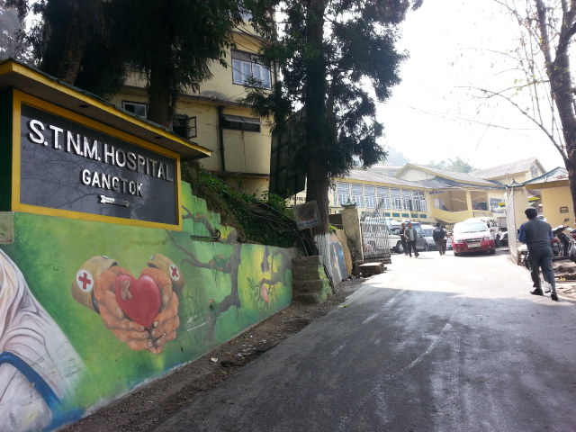

Biomedical Equipment Maintenance Model ( A Joint Study by NHSRC and Mass Biomedicals Pvt. Ltd. New Delhi)
Location:- Sir Thutob Memorial Hospital |  |  |  |  |  | Name of the Head & Ph No.:-Dr.Yogesh Verma , Mob.:- 07872889129
Equip-ment ID | Department |  |  | Equipment Description | Make/ Model No. | Serial Number | Install- ation Date | Functional Status |  | Qty. | Approx. Cost Of Each Equipment | Total Cost Of Equipment
 |  |  |  |  |  |  |  | W | NW
# | ORTHO |  |  | Autoclave (Horizontal) | Yorco | * | * | 1 |  | 1 | 55,000.00 | 55,000.00
# |  |  |  | Boyles Apparatus | Germany, Drager,S-A2 | M33420 | 1998 |  | 1 | 1 | 350,000.00 | 350,000.00
# |  |  |  | Boyles Apparatus | Indian | * | * | 1 |  | 1 | 65,000.00 | 65,000.00
# |  |  |  | Boyles Apparatus | U.S.A, Datex Othem | CAAG00283 | * | 1 |  | 1 | 350,000.00 | 350,000.00
# |  |  |  | C-Arm | Siemens, 08645975 | 3547 | * | 1 |  | 1 | 800,000.00 | 800,000.00
# |  |  |  | Ceiling O.T.Light | Philips | M70G | * | 1 |  | 1 | 150,000.00 | 150,000.00
# |  |  |  | Ceiling O.T.Light | Angenieu | AX4 | * |  | 1 | 1 | 350,000.00 | 350,000.00
# |  |  |  | Domestic Refrigerator | LG,165Ltr. | * | * | 1 |  | 1 | 15,000.00 | 15,000.00
# |  |  |  | Microscope (Operating) | Zeiss | E0351380 | * | 1 |  | 1 | 850,000.00 | 850,000.00
# |  |  |  | Multipara Monitor | Philips,MP-20 | DE72840396 | * | 1 |  | 1 | 135,000.00 | 135,000.00
# |  |  |  | Multipara Monitor | Welch Allym | CMH0382 | * | 1 |  | 1 | 135,000.00 | 135,000.00
# |  |  |  | Needle Destroyer | Hospit Time | * | * | 1 |  | 1 | 1,200.00 | 1,200.00
# |  |  |  | O.T.Table (Hydraulic) | Merivaara | * | * | 1 |  | 1 | 350,000.00 | 350,000.00
# |  |  |  | O.T.Table (Hydraulic) | Cognate | SS251 | * | 1 |  | 1 | 95,000.00 | 95,000.00
# |  |  |  | O.T.Table (Hydraulic) | Cognate | SS251 | * | 1 |  | 1 | 95,000.00 | 95,000.00
# |  |  |  | Pneumatic Compressor | Yarco | * | * | 1 |  | 1 | 175,000.00 | 175,000.00
# |  |  |  | Stretcher | * | * | * | 1 |  | 1 | 3,500.00 | 3,500.00
# |  |  |  | Stretcher Trolley | * | * | * | 1 |  | 1 | 14,000.00 | 14,000.00
# |  |  |  | Suction Machine | Surgi VAC | C-158-017 | * |  | 1 | 1 | 6,500.00 | 6,500.00
# | GYNAE |  |  | Adult Weighing Machine | Crown | * | * | 1 |  | 1 | 2,500.00 | 2,500.00
# |  |  |  | Ambu Bag (Infant) | * | * | * | 1 |  | 1 | 1,100.00 | 1,100.00
# |  |  |  | Baby Weighing Machine | Crown | * | * | 1 |  | 1 | 3,000.00 | 3,000.00
# |  |  |  | Baby Weighing Machine | Crown | * | * | 1 |  | 1 | 3,000.00 | 3,000.00
# |  |  |  | Boyles Apparatus | * | CAAE00181 | * | 1 |  | 1 | 65,000.00 | 65,000.00
# |  |  |  | Boyles Apparatus | Boyle Major | * | * |  | 1 | 1 | 78,000.00 | 78,000.00
# |  |  |  | Boyles Apparatus | Life Line | * | * |  | 1 | 1 | 70,000.00 | 70,000.00
# |  |  |  | Cautery Machine | Digital-400 | E0552327 | * | 1 |  | 1 | 160,000.00 | 160,000.00
# |  |  |  | Ceiling O.T.Light | Angenuex | * | * |  | 1 | 1 | 350,000.00 | 350,000.00
# |  |  |  | Ceiling O.T.Light | Angenuex | * | * | 1 |  | 1 | 350,000.00 | 350,000.00
# |  |  |  | Ceiling O.T.Light | Angenuex | * | * | 1 |  | 1 | 350,000.00 | 350,000.00
# |  |  |  | E.C.G | L&T | 555 | * |  | 1 | 1 | 52,000.00 | 52,000.00
# |  |  |  | Foetal Monitor | BPL-9534 | BQTB8J1535 | 2008 | 1 |  | 1 | 80,000.00 | 80,000.00
# |  |  |  | Fumigator | Foyster-ULV-2200 | * | * | 1 |  | 1 | 4,500.00 | 4,500.00
# |  |  |  | Infant Radiant Warmer | Meditrin | * | * | 1 |  | 1 | 18,000.00 | 18,000.00
# |  |  |  | Infant Radiant Warmer | Martin | * | * |  | 1 | 1 | 18,000.00 | 18,000.00
# |  |  |  | Labor Table | Cognate,Manual | * | * | 1 |  | 1 | 14,000.00 | 14,000.00
# |  |  |  | Labor Table (Hydraulic) | * | * | * | 1 |  | 1 | 25,000.00 | 25,000.00
# |  |  |  | Labor Table (Simple) | * | * | * | 1 |  | 1 | 14,000.00 | 14,000.00
# |  |  |  | Labor Table (Simple) | * | * | * |  | 1 | 1 | 14,000.00 | 14,000.00
# |  |  |  | Labor Table (Simple) | * | * | * | 1 |  | 1 | 14,000.00 | 14,000.00
# |  |  |  | Labor Table (Simple) | * | * | * | 1 |  | 1 | 14,000.00 | 14,000.00
# |  |  |  | Multipara Monitor | Philips,MP-20 | D872840377 | * | 1 |  | 1 | 80,000.00 | 80,000.00
# |  |  |  | O.T.Light | Angenieu,AXU | * | * | 1 |  | 1 | 350,000.00 | 350,000.00
# |  |  |  | SPO2 | Datex,Satlite Trans | 406633 | * |  | 1 | 1 | 54,000.00 | 54,000.00
# |  |  |  | SPO2 | Datex,Omega3800 | FBFE01220 | * |  | 1 | 1 | 54,000.00 | 54,000.00
# |  |  |  | Sterilizer (Medium) | * | * | * | 1 |  | 1 | 6,500.00 | 6,500.00
# |  |  |  | Stretcher Trolley | * | * | * | 2 |  | 2 | 14,000.00 | 28,000.00
# |  |  |  | Suction Machine | Anand | 7F6614 | * | 1 |  | 1 | 6,500.00 | 6,500.00
# |  |  |  |  |  | 7F6618 | * | 1 |  | 1 | 6,500.00 | 6,500.00
# |  |  |  |  | Surgix | * | * | 1 |  | 1 | 6,500.00 | 6,500.00
# |  |  |  |  |  | * | * |  | 1 | 1 | 6,500.00 | 6,500.00
# |  |  |  |  |  | * | * |  | 1 | 1 | 6,500.00 | 6,500.00
# |  |  |  |  |  | * | * |  | 1 | 1 | 6,500.00 | 6,500.00
# |  |  |  | Suction Machine (Foot) | * | * | * | 1 |  | 1 | 3,500.00 | 3,500.00
# |  |  |  | Syringe Destroyer | Hospit Time | * | * | 1 |  | 1 | 1,200.00 | 1,200.00
# |  |  |  | Ultrasound Machine | Siemens,SonolicG20 | * | * | 1 |  | 1 | 450,000.00 | 450,000.00
# |  |  |  | Ventilator | German ,7800 | CAXW00235 | * | 1 |  | 1 | 600,000.00 | 600,000.00
# | GYNAE O.T-2 |  |  | Adult Weighing Machine | Crown | * | * | 1 |  | 1 | 2,500.00 | 2,500.00
# |  |  |  | Boyle Tech | Datex Ohmeda | * | * | 1 |  | 1 | 150,000.00 | 150,000.00
# |  |  |  | Boyles Apparatus | Dragger,Fabius Plus | USAH-0071 | * | 1 |  | 1 | 80,000.00 | 80,000.00
# |  |  |  | Boyles Apparatus | Dragger | ARYB-079 | * | 1 |  | 1 | 350,000.00 | 350,000.00
# |  |  |  | Ceiling O.T.Light | Angenieux,AX4 | * | * | 1 |  | 1 | 350,000.00 | 350,000.00
# |  |  |  | Ceiling O.T.Light | Double Domb | * | * | 1 |  | 1 | 150,000.00 | 150,000.00
# |  |  |  | Colposcope | Olympus-OCS-500 | * | * | 1 |  | 1 | 250,000.00 | 250,000.00
# |  |  |  | Fumigator | Foyester | ULV-2200 | * | 1 |  | 1 | 6,500.00 | 6,500.00
# |  |  |  | Labor Table | Cognate | * | * | 1 |  | 1 | 14,000.00 | 14,000.00
# |  |  |  |  |  | * | * | 1 |  | 1 | 14,000.00 | 14,000.00
# |  |  |  | Labor Table (Hydraulic) | * | * | * | 1 |  | 1 | 25,000.00 | 25,000.00
# |  |  |  | Multipara Monitor | Philips,MP-20 | DE72840388 | * | 1 |  | 1 | 80,000.00 | 80,000.00
# |  |  |  | Sterilizer (Small) | * | * | * | 1 |  | 1 | 6,500.00 | 6,500.00
# |  |  |  | Stretcher | * | * | * | 1 |  | 1 | 6,500.00 | 6,500.00
# |  |  |  | Suction Machine | Surgi VAC | C-273-006 | * | 1 |  | 1 | 6,500.00 | 6,500.00
# |  |  |  | Suction Machine | Yarco | * | * | 1 |  | 1 | 6,500.00 | 6,500.00
# |  |  |  | Suction Machine | Anand | 2J4219 | * |  | 1 | 1 | 6,500.00 | 6,500.00
# |  |  |  | Syringe Destroyer | * | * | * | 1 |  | 1 | 1,200.00 | 1,200.00
# |  |  |  | Autoclave (Horizontal) | Small | * | * |  | 1 | 1 | 55,000.00 | 55,000.00
# |  |  |  | Autoclave (Horizontal) | Large | * | * | 1 |  | 1 | 55,000.00 | 55,000.00
# |  |  |  | Autoclave (Horizontal) | HK-150E | LE-6178 | * |  | 1 | 1 | 55,000.00 | 55,000.00
# |  |  |  | Autoclave (Vertical) | Large | * | * | 1 |  | 1 | 65,000.00 | 65,000.00
# |  |  |  |  |  | * | * | 1 |  | 1 | 65,000.00 | 65,000.00
# |  |  |  |  |  | * | * |  | 1 | 1 | 65,000.00 | 65,000.00
# |  |  |  | Autoclave (Vertical) | Med. | * | * | 1 |  | 1 | 65,000.00 | 65,000.00
# |  |  |  | Boyles Apparatus | Ohemda | * | * |  | 1 | 1 | 170,000.00 | 170,000.00
# |  |  |  | Labor Table (Hydraulic) | * | * | * |  | 1 | 1 | 25,000.00 | 25,000.00
# | N.I.C.U |  |  | Baby Resuscitation Set | Drager,Baby Therm | 2M30284-07-ARZN | * |  | 1 | 1 | 38,000.00 | 38,000.00
# |  |  |  | Baby Weighing Machine | Crown | * | * | 1 |  | 1 | 3,000.00 | 3,000.00
# |  |  |  | Incubator | Dragger,Ohmeda Ohio care | * | * | 1 |  | 1 | 375,000.00 | 375,000.00
# |  |  |  | Incubator | Gurdian-2000 | * | * | 1 |  | 1 | 175,000.00 | 175,000.00
# |  |  |  |  |  | * | * | 1 |  | 1 | 175,000.00 | 175,000.00
# |  |  |  | Infusion Pump | AKSS,Srgu Pump-404 | H11071225 | * | 1 |  | 1 | 40,000.00 | 40,000.00
# |  |  |  | Infusion Pump | * | H12061172 | * |  | 1 | 1 | 40,000.00 | 40,000.00
# |  |  |  | Infusion Pump | * | H11061170 | * |  | 1 | 1 | 40,000.00 | 40,000.00
# |  |  |  | Intensive Care Warmer With Cabinet | Meditrin | * | * | 1 |  | 1 | 18,000.00 | 18,000.00
# |  |  |  | Phototherapy | Meditrin | * | * | 1 |  | 1 | 15,500.00 | 15,500.00
# |  |  |  | Phototherapy |  | * | * | 1 |  | 1 | 15,500.00 | 15,500.00
# |  |  |  | Phototherapy |  | * | * | 1 |  | 1 | 15,500.00 | 15,500.00
# |  |  |  | Phototherapy |  | * | * | 1 |  | 1 | 15,500.00 | 15,500.00
# |  |  |  | Phototherapy |  | * | * | 1 |  | 1 | 15,500.00 | 15,500.00
# |  |  |  | Pulse Oximeter | BPL,Elco | BFMC582519 | * | 1 |  | 1 | 55,000.00 | 55,000.00
# |  |  |  | Pulse Oximeter | * | BFMC5D2426 | * |  | 1 | 1 | 55,000.00 | 55,000.00
# |  |  |  | Pulse Oximeter | * | CMMF8M4517 | * |  | 1 | 1 | 55,000.00 | 55,000.00
# |  |  |  | Radiant Warmer | Meditrin | * | * | 1 |  | 1 | 18,500.00 | 18,500.00
# |  |  |  |  |  | * | * | 1 |  | 1 | 18,500.00 | 18,500.00
# |  |  |  |  |  | * | * | 1 |  | 1 | 18,500.00 | 18,500.00
# |  |  |  |  |  | * | * | 1 |  | 1 | 18,500.00 | 18,500.00
# |  |  |  | Single Port Nebulizer | Dr. Morphen | 009527 | * | 1 |  | 1 | 4,500.00 | 4,500.00
# |  |  |  | Sterilizer (Medium) | * | * | * | 1 |  | 1 | 6,500.00 | 6,500.00
# |  |  |  | Suction Machine | Surgix | H07071197 | * | 1 |  | 1 | 6,500.00 | 6,500.00
# |  |  |  | Suction Machine |  | * | * |  | 1 | 1 | 6,500.00 | 6,500.00
# |  |  |  | Syringe Destroyer | Hospit Time | * | * | 1 |  | 1 | 1,200.00 | 1,200.00
# |  |  |  | Syringe Destroyer |  | * | * | 1 |  | 1 | 1,200.00 | 1,200.00
# |  |  |  | Ventilator | Dragger,Baby Log 8000PLus | ARZM0100 | * | 1 |  | 1 | 350,000.00 | 350,000.00
# | PSYCHIATRIC |  |  | Adult Weighing Machine | Crown | * | * | 1 |  | 1 | 2,500.00 | 2,500.00
# |  |  |  | Boyles Apparatus | Datex Ohmeda | * | * | 1 |  | 1 | 65,000.00 | 65,000.00
# |  |  |  | ECG Machine | Recorder & Medicare | CEG/890018/PHBX | * | 1 |  | 1 | 52,000.00 | 52,000.00
# |  |  |  | ECT Machine | Navigure | * | * |  | 1 | 1 | 150,000.00 | 150,000.00
# |  |  |  | Suction Machine | Surgi VAC | * | * | 1 |  | 1 | 6,500.00 | 6,500.00
# | I.C.U |  |  | B.P.Apparatus | Life Line | * | * | 1 |  | 1 | 650.00 | 650.00
# |  |  |  | Cardiovit | Schiller,CS-200 | 030-01456 | * | 1 |  | 1 | 65,000.00 | 65,000.00
# |  |  |  | Cardiovit | Philips | 9.898E+10 | * |  | 1 | 1 | 65,000.00 | 65,000.00
# |  |  |  | Defibrillator | Philips,M4735A | U300105049 | * | 1 |  | 1 | 170,000.00 | 170,000.00
# |  |  |  | Defibrillator | Philips,M4735A | US00583613 | * | 1 |  | 1 | 170,000.00 | 170,000.00
# |  |  |  | Domestic Refrigerator | Samsung-165Ltr. | * | * | 1 |  | 1 | 12,000.00 | 12,000.00
# |  |  |  | ECG Machine | Philips, Page Writer | USN0821967 | * |  | 1 | 1 | 125,000.00 | 125,000.00
# |  |  |  | ECG Machine |  | USN0021969 | * |  | 1 | 1 | 125,000.00 | 125,000.00
# |  |  |  | ECG Machine |  | USN0821968 | * |  | 1 | 1 | 125,000.00 | 125,000.00
# |  |  |  | ECG Machine |  | USn0821970 | * | 1 |  | 1 | 125,000.00 | 125,000.00
# |  |  |  | ECG Machine | BPL,Cardiant 108T | CGMF7G5038 | * | 1 |  | 1 | 45,000.00 | 45,000.00
# |  |  |  | Enzyme Analyzer | Alerc Triuge,Meterprol | 00072600WW | * | 1 |  | 1 | 85,000.00 | 85,000.00
# |  |  |  | Multipara Monitor | Agilent-V26C | 4006A92769 | * | 1 |  | 1 | 80,000.00 | 80,000.00
# |  |  |  | Multipara Monitor | Agilent-V26C | 4006A92760 | * | 1 |  | 1 | 80,000.00 | 80,000.00
# |  |  |  | Multipara Monitor | Agilent-V26C | 4006A92772 | * | 1 |  | 1 | 80,000.00 | 80,000.00
# |  |  |  | Multipara Monitor | Agilent-V26C | 4006A92671 | * | 1 |  | 1 | 80,000.00 | 80,000.00
# |  |  |  | Patient ICU Bed | Pinque | * | * | 1 |  | 1 | 85,000.00 | 85,000.00
# |  |  |  | Patient ICU Bed | Pinque | * | * | 1 |  | 1 | 85,000.00 | 85,000.00
# |  |  |  | Patient ICU Bed | Pinque | * | * | 1 |  | 1 | 85,000.00 | 85,000.00
# |  |  |  | Syringe Destroyer | * | * | * | 1 |  | 1 | 1,200.00 | 1,200.00
# |  |  |  | Syringe Infusion Pump | ATOM | * | * |  | 1 | 1 | 40,000.00 | 40,000.00
# |  |  |  | Syringe Infusion Pump | SP-500 | 1081670-220EU | * | 1 |  | 1 | 40,000.00 | 40,000.00
# |  |  |  | Syringe Infusion Pump | SP-500 | 1090600-220EU | * | 1 |  | 1 | 40,000.00 | 40,000.00
# |  |  |  | TMT Machine | STM-55 | 47503010618013 | * | 1 |  | 1 | 850,000.00 | 850,000.00
# |  |  |  | TMT Machine (Full Vision) | TMX-425 | 8870 | * | 1 |  | 1 | 1,250,000.00 | 1,250,000.00
# |  |  |  | Ultrasound Machine | Philips,3D Echo | * | * | 1 |  | 1 | 350,000.00 | 350,000.00
# |  |  |  | Ultrasound Machine | HP,Sonos-2000 | * | * |  | 1 | 1 | 450,000.00 | 450,000.00
# | I.C.C.U POST |  |  | Adult Weighing M/C | Crown | * | * | 1 |  | 1 | 2,500.00 | 2,500.00
# |  |  |  | Bed Side Locker | * | * | * | 1 |  | 1 | 3,500.00 | 3,500.00
# |  |  |  | Bed Side Locker | * | * | * | 1 |  | 1 | 3,500.00 | 3,500.00
# |  |  |  | Bed Side Locker | * | * | * | 1 |  | 1 | 3,500.00 | 3,500.00
# |  |  |  | Bed Side Locker | * | * | * | 1 |  | 1 | 3,500.00 | 3,500.00
# |  |  |  | Bed Side Locker | * | * | * | 1 |  | 1 | 3,500.00 | 3,500.00
# |  |  |  | Bed Side Locker | * | * | * | 1 |  | 1 | 3,500.00 | 3,500.00
# |  |  |  | I.C.U Bed | Kendul | * | * | 1 |  | 1 | 85,000.00 | 85,000.00
# |  |  |  | I.C.U Bed | Kendul | * | * | 1 |  | 1 | 85,000.00 | 85,000.00
# |  |  |  | I.C.U Bed | Kendul | * | * | 1 |  | 1 | 85,000.00 | 85,000.00
# |  |  |  | I.C.U Bed | Kendul | * | * | 1 |  | 1 | 85,000.00 | 85,000.00
# |  |  |  | I.C.U Bed | Kendul | * | * | 1 |  | 1 | 85,000.00 | 85,000.00
# |  |  |  | I.C.U Bed | Kendul | * | * | 1 |  | 1 | 85,000.00 | 85,000.00
# |  |  |  | Multipara Monitor | Philips, MP-20 | DE72840358 | * | 1 |  | 1 | 80,000.00 | 80,000.00
# |  |  |  | Multipara Monitor | Philips, MP-20 | DE72840364 | * | 1 |  | 1 | 80,000.00 | 80,000.00
# |  |  |  | Multipara Monitor | Philips, MP-20 | DE72840373 | * | 1 |  | 1 | 80,000.00 | 80,000.00
# |  |  |  | Multipara Monitor | Philips, MP-20 | DE72840391 | * | 1 |  | 1 | 80,000.00 | 80,000.00
# |  |  |  | Multipara Monitor | Philips, MP-20 | DE72840393 | * | 1 |  | 1 | 80,000.00 | 80,000.00
# |  |  |  | Multipara Monitor | Philips, MP-20 | DE72840403 | * | 1 |  | 1 | 80,000.00 | 80,000.00
# |  |  |  | Overhead Table | * | * | * | 1 |  | 1 | 12,000.00 | 12,000.00
# |  |  |  | Overhead Table | * | * | * | 1 |  | 1 | 12,000.00 | 12,000.00
# |  |  |  | Overhead Table | * | * | * | 1 |  | 1 | 12,000.00 | 12,000.00
# |  |  |  | Overhead Table | * | * | * | 1 |  | 1 | 12,000.00 | 12,000.00
# |  |  |  | Overhead Table | * | * | * | 1 |  | 1 | 12,000.00 | 12,000.00
# |  |  |  | Overhead Table | * | * | * | 1 |  | 1 | 12,000.00 | 12,000.00
# |  |  |  | Suction Machine | Surgi-Vac | * | * | 1 |  | 1 | 6,500.00 | 6,500.00
# | DENTAL |  |  | Dental Chair | Cogrident,Model iV | * | * |  | 1 | 1 | 150,000.00 | 150,000.00
# |  |  |  | Dental Chair | Cogrident ,Chamundi | * | * | 1 |  | 1 | 150,000.00 | 150,000.00
# |  |  |  | Dental Chair | * | * | * | 1 |  | 1 | 150,000.00 | 150,000.00
# |  |  |  | Dental Chair | * | * | * | 1 |  | 1 | 150,000.00 | 150,000.00
# |  |  |  | Dental Chair | * | * | * | 1 |  | 1 | 150,000.00 | 150,000.00
# |  |  |  | Sterilizer (Medium) | * | * | * | 1 |  | 1 | 4,500.00 | 4,500.00
# |  |  |  | Sterilizer (Small) | * | * | * | 1 |  | 1 | 3,500.00 | 3,500.00
# |  |  |  | Sterilizer (Small | * | * | * | 1 |  | 1 | 3,500.00 | 3,500.00
# |  |  |  | X-Ray System | Kodec,2001 Intraoral | 24 | 2010 | 1 |  | 1 | 450,000.00 | 450,000.00
# |  |  |  | X-Ray System | Congrigent, Intraas 70 Plus | 12 | 2008 | 1 |  | 1 | 450,000.00 | 450,000.00
# | MAIN O.T |  |  | B.P.Apparatus | Stand | * | * |  | 1 | 1 | 650.00 | 650.00
# |  |  |  | ECG Machine | Cardiant 6108T | AVMN2M2109 | * |  | 1 | 1 | 52,000.00 | 52,000.00
# |  |  |  | Endoscopy Monitor | Sony | 21039113319178 | * | 1 |  | 1 | 200,000.00 | 200,000.00
# |  |  |  | Endoscopy Monitor | * | 21039113319178 | * | 1 |  | 1 | 200,000.00 | 200,000.00
# |  |  |  | Multipara Monitor | BPL,Excello | CRTA8L3716 | * |  | 1 | 1 | 80,000.00 | 80,000.00
# |  |  |  | O.T.Table (Hydraulic) | * | * | * | 1 |  | 1 | 70,000.00 | 70,000.00
# |  |  |  | Adult Weighing M/C | Crown | * | * | 1 |  | 1 | 2,500.00 | 2,500.00
# |  |  |  | Boyles Apparatus | Datex-Ohemda | CAAE00289 | * | 1 |  | 1 | 350,000.00 | 350,000.00
# |  |  |  | Boyles Apparatus | Life Line | 99512 | * | 1 |  | 1 | 65,000.00 | 65,000.00
# |  |  |  | Cautery Machine | L& T | * | * | 1 |  | 1 | 55,000.00 | 55,000.00
# |  |  |  | Cautery Machine | Cuadro D450V1 | 31123 | * | 1 |  | 1 | 55,000.00 | 55,000.00
# |  |  |  | Ceiling O.T. Light | Angenieux,AX4 | 026988 | * | 1 |  | 1 | 26,000.00 | 26,000.00
# |  |  |  | Diathermy | Martin KLS, ME-411 | ME4110303102741 | * | 1 |  | 1 | 350,000.00 | 350,000.00
# |  |  |  | Electronic Endoflator | Storz | FF10073-B | * | 1 |  | 1 | 300,000.00 | 300,000.00
# |  |  |  | Electronic Endoflator | Storz | EB16831-B | * | 1 |  | 1 | 300,000.00 | 300,000.00
# |  |  |  | Endoscope | Autocon 200 | SNKM2733 | * | 1 |  | 1 | 350,000.00 | 350,000.00
# |  |  |  | Endoscope | Unidrive-ECO | BA1218 | * | 1 |  | 1 | 350,000.00 | 350,000.00
# |  |  |  | Endoscope | Storz,TricanSii | LV656886P | * | 1 |  | 1 | 350,000.00 | 350,000.00
# |  |  |  | Endoscope | Storz,Halogen 150 | SNBA50651 | * | 1 |  | 1 | 350,000.00 | 350,000.00
# |  |  |  | Endoscope | * | BA10613 | * | 1 |  | 1 | 350,000.00 | 350,000.00
# |  |  |  | Halothane Vaporizer | USA,Datex-Ohmeda | BEFG00379 | * | 1 |  | 1 | 85,000.00 | 85,000.00
# |  |  |  | Multipara Monitor | Philips,MP-20 | DE72840375 | * | 1 |  | 1 | 80,000.00 | 80,000.00
# |  |  |  | O.T.Table (Hydraulic) | * | * | * | 1 |  | 1 | 70,000.00 | 70,000.00
# |  |  |  | O.T.Table (Hydraulic) | * | * | * | 1 |  | 1 | 70,000.00 | 70,000.00
# |  |  |  | Operating Microscope | Zeiss | 6.628E+09 | * | 1 |  | 1 | 15,500.00 | 15,500.00
# |  |  |  | Operating Microscope | * | 6.629E+09 | * |  | 1 | 1 | 15,500.00 | 15,500.00
# |  |  |  | Operating Microscope | Olympus-SO-161 | * | * | 1 |  | 1 | 15,500.00 | 15,500.00
# |  |  |  | Operating Microscope | Moller- wedel | 1790 | * | 1 |  | 1 | 375,000.00 | 375,000.00
# |  |  |  | Boyel's Apparatus | Datex Ohmeda | CAAG000282 | * | 1 |  | 1 | 55,000.00 | 55,000.00
# |  |  |  | Suction Machine | Surgix,Vac | * | * | 2 |  | 2 | 6,500.00 | 13,000.00
# |  |  |  | Suction Machine |  | 026977 | * | 1 |  | 1 | 26,000.00 | 26,000.00
# | ULTRASOUND |  |  | Ultrasound Machine | Siemens, Acuson x 150 | 91383612 | * | 1 |  | 1 | 375,000.00 | 375,000.00
# | X-Ray |  |  | X-Ray Machine | Philips,Digital Diagnost | 237769 | * | 1 |  | 1 | 450,000.00 | 450,000.00
# |  |  |  | Printer | Kodek, Driview 5850 | 5855- 8369 | * | 1 |  | 1 | 450,000.00 | 450,000.00
# |  |  |  | X-Ray Machine | Siemens,500 mA | 31396 | * | 1 |  | 1 | 450,000.00 | 450,000.00
# |  |  |  | X-Ray Machine | Siemens, 100 mA | 504 | * | 2 |  | 2 | 450,000.00 | 900,000.00
# | Female Surgical Ward |  |  | B.P.Apparatus | Model - Lifeline | * | * | 1 |  | 1 | 650.00 | 650.00
# |  |  |  | Needle Destroyer | * | * | * |  | 1 | 1 | 1,200.00 | 1,200.00
# |  |  |  | Suction Machine | Hi- Vac | * | * |  | 2 | 2 | 6,500.00 | 13,000.00
# | Endoscopy |  |  | Endoscopy Monitor | Sony | 6201220 | * | 1 |  | 1 | 80,000.00 | 80,000.00
# |  |  |  | Bedside Monitor | BPL, CMMOB | CMMG05753 | * |  | 1 | 1 | 85,000.00 | 85,000.00
# |  |  |  | Endoscopy Image Source | Exera CV - 160 | 7105786 | * |  | 1 | 1 | 350,000.00 | 350,000.00
# |  |  |  | Endoscopy Light Source | Exera CV - 160 | 7125036 | * |  | 1 | 1 | 350,000.00 | 350,000.00
# |  |  |  | Endoscopy Image Source | Olympus CV - 180 | 7009459 | * | 1 |  | 1 | 350,000.00 | 350,000.00
# |  |  |  | Endoscopy Light Source |  | 7018354 | * | 1 |  | 1 | 350,000.00 | 350,000.00
# |  |  |  | Suction Machine | Surgi-Vac | C-197-019, C-273-007 | * | 2 |  | 2 | 6,500.00 | 13,000.00
# |  |  |  | Endoscopy Washer | Olympus,EW - 30 | 2210154 | * | 1 |  | 1 | 350,000.00 | 350,000.00
# |  |  |  | Needle Destroyer | Hospitime | * | * | 1 |  | 1 | 1,200.00 | 1,200.00
# | PATHOLOGY |  |  | Centrifuge (8 tube) | Remi, R - 8C | * | * | 1 |  | 1 | 6,500.00 | 6,500.00
# |  |  |  | Centrifuge (8 tube | Remi, R8 | * | * | 1 |  | 1 | 6,500.00 | 6,500.00
# |  |  |  | Serological Water Bath | Yorco | 4101 | * | 2 |  | 2 | 45,000.00 | 90,000.00
# |  |  |  | Binocular Microscope | Olympus,CH20iBIMF | I10D006 | * | 1 |  | 1 | 30,000.00 | 30,000.00
# |  |  |  | Binocular Microscope |  | 6M15227 | * | 1 |  | 1 | 30,000.00 | 30,000.00
# |  |  |  | Binocular Microscope |  | i10D008 | * | 1 |  | 1 | 30,000.00 | 30,000.00
# |  |  |  | Binocular Microscope |  | * | * | 1 |  | 1 | 30,000.00 | 30,000.00
# |  |  |  | Binocular Microscope |  | I10D014 | * | 1 |  | 1 | 30,000.00 | 30,000.00
# |  |  |  | Binocular Microscope |  | I10D006 | * | 1 |  | 1 | 30,000.00 | 30,000.00
# |  |  |  | Deionized Water Plant | Aquachem | * | * | 1 |  | 1 | 150,000.00 | 150,000.00
# |  |  |  | Electrolyte Analyzer | * | * | * | 1 |  | 1 | 175,000.00 | 175,000.00
# |  |  |  | Analyzer | Easy Lyte Lithium | 32776BNKC | * | 1 |  | 1 | 200,000.00 | 200,000.00
# |  |  |  | Analyzer | Easy Lyte Plus | 32122BNKL | * | 1 |  | 1 | 200,000.00 | 200,000.00
# |  |  |  | Analyzer | Model - EM - 200 | 60135 | * |  | 1 | 1 | 1,200,000.00 | 1,200,000.00
# |  |  |  | Analyzer | Model - XL - 600 | 200119 | * | 1 |  | 1 | 450,000.00 | 450,000.00
# |  |  |  | Analyzer | Model - Jolley - 100 | 960686 | * | 1 |  | 1 | 200,000.00 | 200,000.00
# |  |  |  | Analyzer | Model - Jolley - 100 | 960689 | * |  | 1 | 1 | 200,000.00 | 200,000.00
# |  |  |  | Analyzer | Erba Chem 5 plus | 100259 | * |  | 1 | 1 | 200,000.00 | 200,000.00
# |  |  |  | Analyzer | Erba Chem 5 plus | 100285 | * | 1 |  | 1 | 200,000.00 | 200,000.00
# |  |  |  | Elisa Reader | Elisa Scan | 120192 | * | 1 |  | 1 | 200,000.00 | 200,000.00
# |  |  |  | Elisa Washer | * | 430453 | * | 1 |  | 1 | 250,000.00 | 250,000.00
# |  |  |  | Cell Counter | Sysmex | 5800 – 62425 | * | 1 |  | 1 | 350,000.00 | 350,000.00
# |  |  |  | Calorimeter | Systronics | 8705 | * | 1 |  | 1 | 3,500.00 | 3,500.00
# | HAEMODIALYSIS |  |  | Weighing M/C (Digital) | CAS, m/n- DZ- III | 130383605 | * | 1 |  | 1 | 4,500.00 | 4,500.00
# |  |  |  | B.P.Apparatus (Hg) Stand | Lifeline | * | * | 3 | 1 | 4 | 1,100.00 | 4,400.00
# |  |  |  | Dialyzer Machine | Fresenius, 40085 | 2SxAF066 | * | 1 |  | 1 | 2,200,000.00 | 2,200,000.00
# |  |  |  | Dialyzer Machine |  | 2SxAF060 | * | 1 |  | 1 | 2,200,000.00 | 2,200,000.00
# |  |  |  | Dialyzer Machine |  | 2SxAF210 | * | 1 |  | 1 | 2,200,000.00 | 2,200,000.00
# |  |  |  | Dialyzer Machine |  | 2SxAF076 | * | 1 |  | 1 | 2,200,000.00 | 2,200,000.00
# |  |  |  | Dialyzer Machine |  | 2SxAF065 | * | 1 |  | 1 | 2,200,000.00 | 2,200,000.00
# |  |  |  | Bedside Monitor | BPL,Magna | DXMS3079 | * | 1 |  | 1 | 85,000.00 | 85,000.00
# |  |  |  | Bedside Monitor |  | DXMS3075 | * | 1 |  | 1 | 85,000.00 | 85,000.00
# |  |  |  | Bedside Monitor |  | DXMS3080 | * | 1 |  | 1 | 85,000.00 | 85,000.00
# |  |  |  | Bedside Monitor |  | DXMS3072 | * | 1 |  | 1 | 85,000.00 | 85,000.00
# |  |  |  | Bedside Monitor |  | DXMS3077 | * | 1 |  | 1 | 85,000.00 | 85,000.00
# |  |  |  | Bedside Monitor |  | DXMS3055 | * | 1 |  | 1 | 85,000.00 | 85,000.00
# |  |  |  | Patient Bed | * | * | * | 5 |  | 5 | 35,000.00 | 175,000.00
# |  |  |  | Domestic Refrigerator | Samsung, 165 L | R6204PADA00582N | * | 1 |  | 1 | 8,000.00 | 8,000.00
# |  |  |  | Syringe Cutter | * | * | * | 1 |  | 1 | 1,200.00 | 1,200.00
# |  |  |  | Defibrillator | Philips,Heart Start XL | * | * | 1 |  | 1 | 170,000.00 | 170,000.00
# |  |  |  | Glucometer | Accu- chek Active, GC | GC17295192 | * | 1 |  | 1 | 1,400.00 | 1,400.00
# |  |  |  | Ambu Bag (Adult) | * | * | * | 1 |  | 1 | 1,100.00 | 1,100.00
# |  |  |  | Suction Machine | Hi - V ac, Anand | * | * | 1 |  | 1 | 6,500.00 | 6,500.00
# |  |  |  | Oxygen Alarm System | Cronus, Digital | * | * | 1 |  | 1 | 75,000.00 | 75,000.00
# |  |  |  | Liquid Oxygen Plant | I.O.CL,3000Ltr. | * | * |  | 1 | 1 | 1,000,000.00 | 1,000,000.00
# | MICROBIOLOGY |  |  | BOD Incubator | Yorco, m/n - N/A | * | * | 1 | 1 | 2 | 15,000.00 | 30,000.00
# |  |  |  | L.G Defibrillator 200 l | * | * | * | 1 |  | 1 | 170,000.00 | 170,000.00
# |  |  |  | Centrifuge | Remi, m/n- R - 8C | F8LC5599 | * | 1 |  | 1 | 6,500.00 | 6,500.00
# |  |  |  | Laminar Flow | Thermo Scientific | * | * | 1 |  | 1 | 250,000.00 | 250,000.00
# |  |  |  | Refrigerator | LG 200 L | * | * | 1 |  | 1 | 17,000.00 | 17,000.00
# |  |  |  | Microscope (Binocular) | Olympus CH2Oi | 2C07195 | * | 1 |  | 1 | 30,000.00 | 30,000.00
# |  |  |  | Serological Water Bath | Yorco | * | * | 2 |  | 2 | 45,000.00 | 90,000.00
# |  |  |  | VDRL Rotator | Yorco | * | * | 1 |  | 1 | 4,500.00 | 4,500.00
# |  |  |  | Elisa Reader | Robonik, Readwell Touch | RT0150709R8K | * | 1 |  | 1 | 200,000.00 | 200,000.00
# |  |  |  | Elisa Washer | Robonik Washwell Touch | * | * | 1 |  | 1 | 250,000.00 | 250,000.00
# |  |  |  | Electronic Balance | * | * | * |  | 1 | 1 | 12,000.00 | 12,000.00
# | ULTRASOUND |  |  | Refrigerator | Samsung, 230 L | * | * | 1 |  | 1 | 18,000.00 | 18,000.00
# |  |  |  | Elisa Reader | Lab system, Thermofisher | 3.521E+09 | * | 1 |  | 1 | 200,000.00 | 200,000.00
# |  |  |  | Elisa Washer | Lab system, Thermofisher | 006-9-1090 | * | 1 |  | 1 | 250,000.00 | 250,000.00
# |  |  |  | Hot Air Oven (Small) | * | 4139 | * |  | 1 | 1 | 4,500.00 | 4,500.00
# |  |  |  | Hot Air Oven (Medium) | * | 202877 | * | 1 |  | 1 | 4,500.00 | 4,500.00
# |  |  |  | Refrigerator | LG , 165 L | * | * | 1 |  | 1 | 13,000.00 | 13,000.00
# |  |  |  | Incubator (Small) | * | 442688 | * |  | 1 | 1 | 8,500.00 | 8,500.00
# |  |  |  | Water Bath | Yorco, m/n - N/A | * | * |  | 1 | 1 | 3,500.00 | 3,500.00
# |  |  |  | Refrigerator | Videocon, 300 L | * | * | 1 |  | 1 | 20,000.00 | 20,000.00
# |  |  |  | Refrigerator | Goodrej, 200 L | * | * |  | 1 | 1 | 15,000.00 | 15,000.00
# |  |  |  | Autoclave (V) (Medium) | Yorco | * | * |  | 1 | 1 | 70,000.00 | 70,000.00
# |  |  |  | Autoclave (V) (Small) | Yarco | * | * |  | 1 | 1 | 65,000.00 | 65,000.00
# |  |  |  | Mono Quartz | Distin unit, Borosil | * | * | 1 |  | 1 | 6,000.00 | 6,000.00
# |  |  |  | Sterilizer (Medium) | * | * | * | 1 |  | 1 | 4,500.00 | 4,500.00
# |  |  |  | Balance | Balaji | * | * | 1 |  | 1 | 4,500.00 | 4,500.00
# |  |  |  | Autoclave (V)(Medium) | * | * | * |  | 2 | 2 | 65,000.00 | 130,000.00
# | BLOOD BANK |  |  | Blood Donor Couch | Insignia | * | * | 2 |  | 2 | 75,000.00 | 150,000.00
# |  |  |  | BCM | Hicare, HLL | 906553 | * | 1 |  | 1 | 65,000.00 | 65,000.00
# |  |  |  | BCM | Insigni,BCM35X | 1040805 | * | 1 |  | 1 | 65,000.00 | 65,000.00
# |  |  |  | B.P.Apparatus (Hg) (Stand) | * | * | * | 2 |  | 2 | 1,100.00 | 2,200.00
# |  |  |  | Adult Weighing M/C | Krups | * | * | 1 |  | 1 | 2,500.00 | 2,500.00
# |  |  |  | Baby weighing M/C | Docbel Braun | * | * | 2 |  | 2 | 3,000.00 | 6,000.00
# |  |  |  | Calorimeter | Erba Inc.,AE-11M | 219979 | * | 1 |  | 1 | 3,500.00 | 3,500.00
# |  |  |  | Cutter | * | * | * | 1 |  | 1 | 1,200.00 | 1,200.00
# |  |  |  | B.B.R | Insignia, BRC - 144x | * | * | 1 |  | 1 | 250,000.00 | 250,000.00
# |  |  |  | Blood Bank Refrigerator | Remi, BR-120 Ultra | * | * | 1 |  | 1 | 250,000.00 | 250,000.00
# |  |  |  | Centrifuge (16 tube) | Remi, m/n- R-8C | 1855 | * | 1 |  | 1 | 6,500.00 | 6,500.00
# |  |  |  | Refrigerator | Kelvinator | * | * | 1 |  | 1 | 8,500.00 | 8,500.00
# |  |  |  | Water Bath | Local Scientific | * | * | 1 |  | 1 | 4,500.00 | 4,500.00
# |  |  |  | Binocular Microscope | Nicon | 247368 | * |  | 1 | 1 | 18,000.00 | 18,000.00
# |  |  |  | Hot Air Oven | Yorco | * | * | 2 |  | 2 | 4,500.00 | 9,000.00
# |  |  |  | Incubator | * | * | * |  | 1 | 1 | 8,500.00 | 8,500.00
# |  |  |  | Refrigerator | Goodrej, 165 L | * | * | 1 |  | 1 | 13,000.00 | 13,000.00
# |  |  |  | Elisa Reader | Touchwell | RT0908RBK176 | * | 1 |  | 1 | 225,000.00 | 225,000.00
# |  |  |  | Elisa Washer | Washwell | * | * | 1 |  | 1 | 225,000.00 | 225,000.00
# |  |  |  | Elisa Reader | Labsystem | 3520900498 | * | 1 |  | 1 | 200,000.00 | 200,000.00
# |  |  |  | Elisa Washer | Labsystem | 0069 – 1091 | * | 1 |  | 1 | 250,000.00 | 250,000.00
# |  |  |  | Refrigerator | Kelvinator 60 L | * | * | 1 |  | 1 | 6,500.00 | 6,500.00
# |  |  |  | Incubator | Yorco | * | * |  | 1 | 1 | 8,500.00 | 8,500.00
# |  |  |  | Water distillation Plant | * | * | * | 1 |  | 1 | 6,000.00 | 6,000.00
# | EYE |  |  | A-Scan | Biomedix | 1722 | * | 1 |  | 1 | 450,000.00 | 450,000.00
# |  |  |  | A-Scan | OT1 Scan/A-13 Scan | * | * |  | 1 | 1 | 85,000.00 | 85,000.00
# |  |  |  | B Scan | * | * | * |  | 1 | 1 | 90,000.00 | 90,000.00
# |  |  |  | VAR Machine Octopus | * | 851 | * | 1 |  | 1 | 250,000.00 | 250,000.00
# |  |  |  | Slit Lamp | 304JSN | 3294 | * |  | 1 | 1 | 13,000.00 | 13,000.00
# |  |  |  | Laser Yag | Yag Lazer Yag - II | 820208 | * |  | 1 | 1 | 450,000.00 | 450,000.00
# |  |  |  | Auto Refrectometer | URK - 07 | K7HI139E | * | 1 |  | 1 | 50,000.00 | 50,000.00
# |  |  |  | Slit Lamp | * | 91955324 | * | 1 |  | 1 | 13,000.00 | 13,000.00
# |  |  |  | Indirect Ophthalmoscope | HEINE | 1.121E+09 | * | 1 |  | 1 | 15,500.00 | 15,500.00
# |  |  |  | Refrectometer | URK - 700 | K7HLC2e | * | 1 |  | 1 | 45,000.00 | 45,000.00
# |  |  |  | Lensometer | GL 7000 | Z16353D | * | 1 |  | 1 | 45,000.00 | 45,000.00
# |  |  |  | Non Cont. Tonometer | Appaswamy | * | * | 1 |  | 1 | 170,000.00 | 170,000.00
# |  |  |  | Retinoscope | Heines | * | * | 1 |  | 1 | 45,000.00 | 45,000.00
# |  |  |  | Ophthalmoscope | Heines | * | * | 1 |  | 1 | 15,500.00 | 15,500.00
# |  |  |  | Ophthalmoscope | Welch Allyn | * | * | 1 |  | 1 | 15,500.00 | 15,500.00
# |  |  |  | Retinoscope | Heines | * | * | 1 |  | 1 | 45,000.00 | 45,000.00
# |  |  |  | Slit Lamp | Haeg Striest | 12467 | * | 1 |  | 1 | 80,000.00 | 80,000.00
# | EYE |  |  | Ophthalmoscope | Heines | * | * | 1 |  | 1 | 15,500.00 | 15,500.00
# |  |  |  | Ophthalmoscope | Killer | * | * |  | 1 | 1 | 15,000.00 | 15,000.00
# | EYE O.T |  |  | Operating Microscope | Karl Ziess | * | * |  | 1 | 1 | 375,000.00 | 375,000.00
# |  |  |  | Phaco Machine | Oertli | VC – 830106 | * | 1 |  | 1 | 350,000.00 | 350,000.00
# |  |  |  | Phaco Machine | switzerland | VC – 830200 | * | 1 |  | 1 | 350,000.00 | 350,000.00
# |  |  |  | Anesthesia Monitor | MP20 Intellivue | DE7284375 | * | 1 |  | 1 | 450,000.00 | 450,000.00
# |  |  |  | Anesthesia Monitor | Philips, | DE72840367, | * | 1 |  | 1 | 450,000.00 | 450,000.00
# |  |  |  | Tonometer | Goldman | * | * |  | 1 | 1 | 250,000.00 | 250,000.00
# |  |  |  | Operating Microscope | Optiscan | * | * |  | 1 | 1 | 375,000.00 | 375,000.00
# |  |  |  | Operating Microscope | Moller- wedel | * | * | 1 |  | 1 | 375,000.00 | 375,000.00
# |  |  |  | Operating Microscope | Olympus | * | * |  | 1 | 1 | 375,000.00 | 375,000.00
# |  |  |  | Slit Lamp | Takaki | * | * |  | 1 | 1 | 13,000.00 | 13,000.00
# | CARDILOGY |  |  | Suction Machine | Anand | * | * | 1 |  | 1 | 6,500.00 | 6,500.00
# |  |  |  | Syringe Cutter | * | * | * |  | 1 | 1 | 1,200.00 | 1,200.00
# |  |  |  | ENT Unit | Entermed , Micronomic 50 | 12804122 | * |  | 1 | 1 | 175,000.00 | 175,000.00
# |  |  |  | Endoscope | Carlziess 1986 german | 3.034E+09 | * |  | 1 | 1 | 850,000.00 | 850,000.00
# |  |  |  | ENT Unit | * | * | * |  | 1 | 1 | 150,000.00 | 150,000.00
# |  |  |  | Suction Machine | Anand, Hi Vac | * | * | 1 |  | 1 | 6,500.00 | 6,500.00
# |  |  |  | Operating Microscope | Ziess Opmifc | * | * | 1 |  | 1 | 1,200,000.00 | 1,200,000.00
# |  |  |  | ENT Unit with chair | Atmos Systema | * | * |  | 1 | 1 | 200,000.00 | 200,000.00
# | Forencic Medicine |  |  | Mortuary Chamber | 4x2 (body) | * | * | 1 | 1 | 2 | 600,000.00 | 1,200,000.00
# |  |  |  | Grossing table (Hydraulic) | Yorco | * | * |  | 2 | 2 | 150,000.00 | 300,000.00
# |  |  |  | Incinerator | 50 kg | * | * | 1 |  | 1 | 3,000,000.00 | 3,000,000.00
# |  |  |  | Microwave | Micromak - 50 | * | * |  | 1 | 1 | 300,000.00 | 300,000.00
# |  |  |  | Shredder | 50 Kg, Siemens | * | * | 1 |  | 1 | 85,000.00 | 85,000.00
# | HISTOPATHOLOGY |  |  | Automatic Tissue Processor | Leica, m/n- TP 1020 | * | * |  | 1 | 1 | 450,000.00 | 450,000.00
# |  |  |  | Cytospin Centrifuge | Thermo Scientific | CY6908 100g | * | 1 |  | 1 | 250,000.00 | 250,000.00
# |  |  |  | Hot Air Oven | Yorco | 02L2995 | * | 1 |  | 1 | 4,500.00 | 4,500.00
# |  |  |  | Water bath Tissue Plantation | Leica RM2125RT | 45737987 | * | 1 |  | 1 | 15,000.00 | 15,000.00
# |  |  |  | Water bath Tissue Plantation | JP Selecta | 337167 | * | 1 |  | 1 | 35,000.00 | 35,000.00
# | PHYSIOTHERAPY |  |  | Short Wave Diathermy | MEGA PULSE SENIOR265 | * | * |  | 1 | 1 | 650,000.00 | 650,000.00
# |  |  |  | Short Wave Diathermy | MEGA PULSE SENIOR265 | * | * |  | 1 | 1 | 650,000.00 | 650,000.00
# |  |  |  | TENS | MULTIDYNE – 965 | * | * |  | 1 | 1 | 65,000.00 | 65,000.00
# |  |  |  | Paraffin Wax Bath | - | * | * |  | 1 | 1 | 25,000.00 | 25,000.00
# |  |  |  | Paraffin Wax Bath | - | * | * | 1 |  | 1 | 25,000.00 | 25,000.00
# |  |  |  | TENS | PHYSIOTENS – 4000 | * | * |  | 1 | 1 | 4,500.00 | 4,500.00
# |  |  |  | Traction | TM 400 | * | * |  | 1 | 1 | 350,000.00 | 350,000.00
# |  |  |  | Hydrotherapy | - | * | * |  | 1 | 1 | 65,000.00 | 65,000.00
# |  |  |  | Therasonic Ultrasound | Therasonic | * | * |  | 1 | 1 | 25,000.00 | 25,000.00
# |  |  |  | Ultrasound | Physio sound | * | * | 1 |  | 1 | 18,000.00 | 18,000.00
# |  |  |  | Ultrasound | Physio sound | * | * | 1 |  | 1 | 18,000.00 | 18,000.00
# | CSSD |  |  | Autoclave (H) | Steri, | 110-1810 | * | 1 |  | 1 | 450,000.00 | 450,000.00
# |  |  |  | Sterilizer Cooker Type) | * | * | * | 1 |  | 1 | 26,500.00 | 26,500.00
Note
 |  |  |  |  |  |  |  |  | Total No. Of Equipment |  |  | 406
# |  | Not Created / Not Found |  |  |  | No. Of Bed's | 300 |  | Total Equipment Cost |  |  | 64,819,850.00
* |  | Not Available |  |  |  | No. Of Staff |  |  | Total CMC Value |  |  | 4,537,389.50

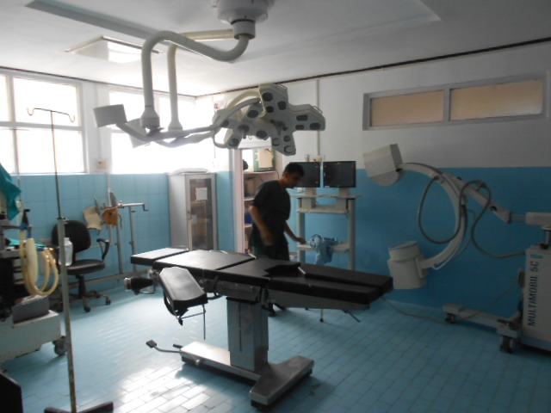
Biomedical Equipment Maintenance Model ( A Joint Study by NHSRC and Mass Biomedicals Pvt. Ltd., New Delhi)
Location :- District Hospital Singtam |  |  |  |  | Name of the Head & Ph No :-  Dr. Tshearing Lhaden ; Mob: 9434178992
Equipment ID | Department | Equipment Description | Model Number | Serial Number | Installation Date | Functional Status |  | Qty. | Approx. Cost of Each Equipment | Total Cost Of Equipment
 |  |  |  |  |  | W | NW
# | O.T | O.T.Table | Indian | * | * | 1 |  | 1 | 45000.00 | 45000.00
# |  | Examination Light | * | * | * | 1 |  | 1 | 8000.00 | 8000.00
# |  | E.C.G | BPL,Cardiart 6108T | AVMN2L20304 | * | 1 |  | 1 | 52000.00 | 52000.00
# |  |  |  | AVMN2C19504 | * | 1 |  | 1 | 52000.00 | 52000.00
# |  |  | BPL,Cardiart 6208 | AIIG0037 | * | 1 |  | 1 | 52000.00 | 52000.00
# |  |  | BPL,Cardiart View | DDTO216926 | * | 1 |  | 1 | 52000.00 | 52000.00
# |  | T.M.T Machine | Schiler,594 xl | 6011302842 | * |  | 1 | 1 | 52000.00 | 52000.00
# |  | Hot Air Sterilizer | Yarco,YSI-431 | 0182804 | * | 1 |  | 1 | 25000.00 | 25000.00
# |  | B.P.Apparatus | Life Line | * | * | 1 |  | 1 | 650.00 | 650.00
# |  | B.P.Apparatus (Stand) | * | 233837 | * | 1 |  | 1 | 1100.00 | 1100.00
# |  | Stretcher Trolley | * | * | * | 1 |  | 1 | 14000.00 | 14000.00
# |  | Needle Destroyer | * | * | * |  | 1 | 1 | 1200.00 | 1200.00
# |  | X-Ray Machine | * | * | * |  | 2 | 2 | 450000.00 | 900000.00
# |  | Sterilizer (Small) | * | * | * |  | 1 | 1 | 6500.00 | 6500.00
# |  | Suctioin Machine | Surgix | * | * | 1 |  | 1 | 6500.00 | 6500.00
# |  | Autoclave (Horizontal) | Indian | * | * | 1 | 1 | 2 | 55000.00 | 110000.00
# |  | Ceiling O.T.Light | Indian | * | * | 1 |  | 1 | 26000.00 | 26000.00
# |  | Suction Machine | Indian | * | * | 4 |  | 4 | 6500.00 | 26000.00
# |  | Radiant Warmer | Indian | * | * | 1 |  | 1 | 38000.00 | 38000.00
# |  | Needle Destroyer | * | * | * | 1 |  | 1 | 1200.00 | 1200.00
# |  | B.P.Apparatus (Stand) | * | * | * | 1 |  | 1 | 1100.00 | 1100.00
# |  | Baby Weighing Machine | * | * | * | 1 |  | 1 | 2500.00 | 2500.00
# |  | O.T.Table (Simple) | * | * | * | 1 |  | 1 | 14000.00 | 14000.00
# |  | Nebulizer (Single Port) | Italian | * | * | 1 |  | 1 | 4500.00 | 4500.00
# |  | B.P.Apparatus | Indian | * | * | 1 |  | 1 | 650.00 | 650.00
# |  | Centrifuge | Remi,R-8C | BDLC-8647 | * | 1 |  | 1 | 6500.00 | 6500.00
# |  | Cerological Water Bath | Remi, | * | * | 1 |  | 1 | 45000.00 | 45000.00
# |  | X-Ray Machine | Siemens,5201 | 017023/24 | * | 1 |  | 1 | 450000.00 | 450000.00
# | PHYSIOTHERAPY | Muscle Stimulator | I.E.M,PhysiostimO.T | * | * | 1 |  | 1 | 12500.00 | 12500.00
# |  | Multi Tens | * | * | * | 1 |  | 1 | 900.00 | 900.00
# |  | Static Cycle | * | * | * | 1 |  | 1 | 2500.00 | 2500.00
# |  | Short Wave Diathermy | I.E.M | * | * |  | 1 | 1 | 85000.00 | 85000.00
# |  | Ultrasound Machine | I.E.M | * | * | 1 |  | 1 | 650000.00 | 650000.00
# |  | Multi Tens | I.E.M | * | * | 1 |  | 1 | 900.00 | 900.00
# |  | Cervical Traction | Medilap | * | * | 1 |  | 1 | 25500.00 | 25500.00
# |  | Shoulder Wheel | Mechanical | * | * |  | 1 | 1 | 6500.00 | 6500.00
# | EYE | Eye Slit Lamp | * | * | * | 1 |  | 1 | 110000.00 | 110000.00
# |  | Opthalmoscope | Heine, | * | * | 1 |  | 1 | 10500.00 | 10500.00
# |  | Opthalmoscope With Lens | Heine,Omega 500 | * | * | 1 |  | 1 | 19500.00 | 19500.00
# |  | Yag - Lazer | Nidac,YC-1600 | 61760 | * |  | 1 | 1 | 450000.00 | 450000.00
# |  | Auto Refractometer | URK-700 | K7HLC2D | * | 1 |  | 1 | 450000.00 | 450000.00
# |  | Retinoscope | Heine,Beta-200 | * | * | 1 |  | 1 | 22500.00 | 22500.00
# | EYE O.T | Sterilizer (Small) | * | * | * | 1 |  | 1 | 6500.00 | 6500.00
# |  | O.T.Table | Indian | * | * | 2 |  | 2 | 14000.00 | 28000.00
# |  | Operating Microscope | HS Moller,FS1-12 | 411 | * |  | 1 | 1 | 15500.00 | 15500.00
# |  | Operating Microscope | Wodel Int.FS1-12 | 676 | * | 1 |  | 1 | 15500.00 | 15500.00
# |  | Flash Autoclave | SA-232X-F-A100 | 090202010-013 | * |  | 1 | 1 | 350000.00 | 350000.00
# | DENTAL | Dental Chair | iv | * | * | 2 |  | 2 | 150000.00 | 300000.00
# |  | Incubator | Confident | * | * |  | 1 | 1 | 8500.00 | 8500.00
# |  | Sterilizer (Small) | * | * | * | 1 |  | 1 | 6500.00 | 6500.00
# |  | Compressor | * | * | * |  | 1 | 1 | 10000.00 | 10000.00
# | PATHOLOGY | Weighing M/C (Adult) | * | * | * | 1 |  | 1 | 1500.00 | 1500.00
# |  | Microscope (Binocular) | Olympus,Ch20IBiMF | 6M15216 | * | 1 |  | 1 | 2500.00 | 2500.00
# |  | Biochemistry Analyzer | Transasia,KX-21 | KX-B5608 | * | 1 |  | 1 | 200000.00 | 200000.00
# |  | Analyzer | Easy Lite PlusBM-200 | NAKCl-34580 | * | 1 |  | 1 | 200000.00 | 200000.00
# |  |  | Transasia,Ebrachem-5PLus | 100271 | * | 1 |  | 1 | 200000.00 | 200000.00
# |  | Rotary Shaker | Remi,RS-1Z | GXZM-984 | * | 1 |  | 1 | 28000.00 | 28000.00
# |  | Microscope (Binocular) | Olympus,CH2oiBIMF | 3D12676 | * | 1 |  | 1 | 15500.00 | 15500.00
# |  | Water Plant | Aqya Chem,OT-20 | 100310 | * | 1 |  | 1 | 150000.00 | 150000.00
# |  | Calorimeter | 115 | * | * |  | 1 | 1 | 1400.00 | 1400.00
# |  | Centrifuge | Remi,R-8C | BDLC-2647 | * |  | 1 | 1 | 6500.00 | 6500.00
# |  | Cerotological Water Bath | Yarco | * | * | 1 |  | 1 | 8500.00 | 8500.00
# |  | Incubator | Yarco,Ysi-431 | 0182802 | * | 1 |  | 1 | 8500.00 | 8500.00
# |  | Baby Weighing Machine | Digital | * | * | 2 |  | 2 | 1500.00 | 3000.00
# |  | Adult Weighing Machine | Analog | * | * | 2 |  | 2 | 3000.00 | 6000.00
# |  | Height Scale | * | * | * | 2 |  | 2 | 3000.00 | 6000.00
# | LABOUR ROOM | Phototherapy | Meditrin | * | * |  | 1 | 1 | 16000.00 | 16000.00
# |  | B.P.Apparatus | FLCO | Life Line | * | 1 |  | 1 | 450.00 | 450.00
# |  | Labour Table (Hydrolic) | * | * | * | 3 |  | 3 | 25000.00 | 75000.00
# |  | Ceilling O.T.Light | * | * | * | 1 |  | 1 | 26000.00 | 26000.00
# |  | Examination Light | * | * | * | 1 |  | 1 | 8000.00 | 8000.00
# |  | Syringe Cutter | * | * | * | 1 |  | 1 | 1200.00 | 1200.00
# |  | Sterilizer (Midium) | * | * | * | 1 |  | 1 | 15000.00 | 15000.00
# |  | Hot Air Sterilizer | Yarco,Ysi-438 | 0181827 | * | 1 |  | 1 | 25000.00 | 25000.00
# |  | Suction Machine | Surgi-Vac | * | * | 1 |  | 1 | 6500.00 | 6500.00
# |  | Infant Radiant Warmer | Neotech | 141501003390 | * | 1 |  | 1 | 38000.00 | 38000.00
# |  | Baby Weighing Machine | Analog | * | * | 1 |  | 1 | 2500.00 | 2500.00
# |  | Suction Machine (Foot) | * | * | * | 1 |  | 1 | 2500.00 | 2500.00
# |  | Stretcher Trolley | * | * | * | 1 |  | 1 | 14000.00 | 14000.00
# |  | B.P.Apparatus (Stand) | Life X | 98134312 | * | 1 |  | 1 | 1100.00 | 1100.00
# |  | Syringe Cutter | Hospitime | * | * | 1 |  | 1 | 1200.00 | 1200.00
# |  | B.P.Apparatus | Life-Line | * | * | 1 |  | 1 | 450.00 | 450.00
# |  | B.P.Apparatus | Spectro Plus | * | * | 1 |  | 1 | 450.00 | 450.00
# | ULTRASOUND | Ultrasound Machine | Maestros,UT Scan | 21480383 | * | 1 |  | 1 | 350000.00 | 350000.00
# |  | B.P.Apparatus | Life-Line | * | * | 1 |  | 1 | 650.00 | 650.00
# | N.B.S.U | Phototherapy Unit With Basinet | Meditrin,Tender Care | * | * | 1 |  | 1 | 32000.00 | 32000.00
# |  | Phototherapy Unit With Basinet | Meditrin | * | * | 1 |  | 1 | 32000.00 | 32000.00
# |  | Oxygen Concentrator | Nidek,920ST | 1121116 | * | 1 |  | 1 | 45000.00 | 45000.00
# |  | Needle Destroyer | * | * | * | 1 |  | 1 | 1200.00 | 1200.00
# |  | Baby Weighing Machine | Digital | * | * | 1 |  | 1 | 1500.00 | 1500.00
# |  | Suction Machine (Foot) | * | * | * | 1 |  | 1 | 2500.00 | 2500.00
# |  | Sterilizer (Cooker Type) | * | * | * | 1 |  | 1 | 15000.00 | 15000.00
# | MORTUARY & B M Waste Management | Accelerator | * | * | * | 1 |  | 1 | 400000.00 | 400000.00
# |  | Incrinerator | Uni Control | 088 | * | 1 |  | 1 | 2500000.00 | 2500000.00
# |  | Sterilizer | Yarco | * | * | 1 |  | 1 | 450000.00 | 450000.00
# |  | Shreder | Yarco | * | * | 1 |  | 1 | 350000.00 | 350000.00
# |  | Body Cabinet | Yarco | * | * | 1 |  | 1 | 800000.00 | 800000.00
Note
 |  |  |  |  |  |  | Total No. Of Equipment |  |  | 109
# | Not Created / Not Found |  |  | No. Of Bed | 100 |  | Total Equipment Cost |  |  | 10,630,800.00
* | Not Available |  |  | No. Of Staff |  |  | Total CMC Value |  |  | 744,156.00

Biomedical Equipment Maintenance Model ( A Joint Study by NHSRC and Mass Biomedicals Pvt. Ltd., New Delhi)
Location:- C.H.C Rhenock |  |  |  |  |  |  |  | Name of the Head & Ph No.: Dr. Anjana, Mob.:-9679008744
Equipment ID |  | Department |  | Equipment Description |  | Model No. |  | Serial Number |  | Installation Date |  | Functional Status |  |  |  | Qty. |  | Approx. Cost of Each Equipment |  | Total Cost Of Equipment
 |  |  |  |  |  |  |  |  |  |  |  | W |  | NW
# |  | Path Lab |  | Biochemistry Analyzer |  | Erba,Chem – 5 |  | 100279 |  | * |  | 1 |  |  |  | 1 |  | 225,000.00 |  | 225,000.00
# |  |  |  | Microscope |  | Nikon, YS2 - H |  | 247158 |  | * |  | 1 |  |  |  | 1 |  | 18,000.00 |  | 18,000.00
# |  |  |  | Microscope |  | Olympus |  | 116Do17 |  | * |  |  |  | 1 |  | 1 |  | 18,000.00 |  | 18,000.00
# |  |  |  | Microscope |  | Single |  | 23836 |  | * |  | 1 |  |  |  | 1 |  | 15,500.00 |  | 15,500.00
# |  |  |  | Digital Calorimeter |  | Systronics, 112 |  | 9244 |  | * |  |  |  | 1 |  | 1 |  | 8,000.00 |  | 8,000.00
# |  |  |  | Digital Calorimeter |  | Alonicro |  | * |  | * |  | 1 |  |  |  | 1 |  | 8,000.00 |  | 8,000.00
# |  |  |  | Oven |  | Yorco, YSI 431 |  | 1604573 |  | * |  | 1 |  |  |  | 1 |  | 4,500.00 |  | 4,500.00
# |  |  |  | Water bath |  | * |  | * |  | * |  | 1 |  |  |  | 1 |  | 3,500.00 |  | 3,500.00
# |  |  |  | Centrifuge ( 8 Tube) |  | * |  | * |  | * |  | 1 |  |  |  | 1 |  | 18,000.00 |  | 18,000.00
# |  |  |  | Needle destroyer |  | Hospittine |  | * |  | * |  | 1 |  |  |  | 1 |  | 1,200.00 |  | 1,200.00
# |  |  |  | Refrigerator |  | Godrej, GDN - 185 B |  | 100601970 |  | * |  | 1 |  |  |  | 1 |  | 18,000.00 |  | 18,000.00
# |  | Dental Room |  | Sterilizer |  | * |  | * |  | * |  | 1 |  |  |  | 1 |  | 6,500.00 |  | 6,500.00
# |  |  |  | Dental Chair |  | Confident |  | * |  | * |  |  |  | 1 |  | 1 |  | 150,000.00 |  | 150,000.00
# |  | Labor Room |  | Radiant Warmer |  | Meditrin |  | * |  | * |  | 1 |  |  |  | 1 |  | 85,000.00 |  | 85,000.00
# |  |  |  | Phototherapy |  | Meditrin |  | * |  | * |  |  |  | 1 |  | 1 |  | 16,000.00 |  | 16,000.00
# |  |  |  | Baby Weighing Machine |  | * |  | * |  | * |  | 1 |  |  |  | 1 |  | 3,000.00 |  | 3,000.00
# |  |  |  | Sterilizer |  | * |  | * |  | * |  | 1 |  |  |  | 1 |  | 6,500.00 |  | 6,500.00
# |  |  |  | Ambu Bag |  | * |  | * |  | * |  | 2 |  |  |  | 2 |  | 1,100.00 |  | 2,200.00
# |  | O.T. |  | Ceiling O T Light (7 bulb) |  | Cognate, India, CLH-7 |  | * |  | * |  |  |  | 1 |  | 1 |  | 70,000.00 |  | 70,000.00
# |  |  |  | Hydraulic O.T Table |  | Cognate, India, CLH- |  | * |  | * |  |  |  | 1 |  | 1 |  | 70,000.00 |  | 70,000.00
# |  |  |  | Autoclave Vertical |  | Lifex |  | * |  | * |  | 1 |  |  |  | 1 |  | 65,000.00 |  | 65,000.00
# |  | Emergency |  | Sterilizer |  | * |  | * |  | * |  | 1 |  |  |  | 1 |  | 6,500.00 |  | 6,500.00
# |  |  |  | Sterilizer |  | * |  | * |  | * |  | 1 |  |  |  | 1 |  | 6,500.00 |  | 6,500.00
# |  |  |  | Needle destroyer |  | Ramfest |  | * |  | * |  | 1 |  |  |  | 1 |  | 1,100.00 |  | 1,100.00
# |  |  |  | Baby Weighing Machine |  | * |  | * |  | * |  | 1 |  |  |  | 1 |  | 3,000.00 |  | 3,000.00
# |  |  |  | Nebulizer |  | * |  | 658537 |  | * |  | 1 |  |  |  | 1 |  | 8,500.00 |  | 8,500.00
# |  |  |  | Suction |  | Surgy - VAC |  | C92016 |  | * |  | 1 |  |  |  | 1 |  | 9,910.00 |  | 9,910.00
NOTE
 |  |  |  |  |  |  |  |  |  |  |  |  |  | Total No.Of Equipment |  |  |  |  |  | 28
# |  | Not Created / Not Found |  |  |  |  |  | No. Of Beds |  | 100 |  |  |  | Total Equipment Cost |  |  |  |  |  | 847,410.00
* |  | Not Available |  |  |  |  |  | No. of Staff |  | 47 |  |  |  | Total CMC Cost |  |  |  |  |  | 59,318.70
Biomedical Equipment Maintenance Model ( A Joint Study by NHSRC and Mass Biomedicals Pvt. Ltd., New Delhi.)
Location:- P.H.C Rangpo |  |  |  |  |  |  | Name of the Head & Ph No.:-Dr. Manoj, Mob.:- 0779777068
Equipment ID | Department |  | Equipment Description |  | Make/Model No. |  | Serial Number |  | Installation Date |  | Functional Status |  |  |  | Qty. |  | Approx. Cost Of Each Equipment |  | Total Cost Of Equipment
 |  |  |  |  |  |  |  |  |  |  | W |  | NW
# | DENTAL LAB |  | Dental Chair |  | Dabi Italiana, M/N -Crome, |  | * |  | * |  |  |  | 1 |  | 1 |  | 150,000.00 |  | 150,000.00
# |  |  | Biochemistry Analyzer |  | Transasia, M/n - Ibra -Chem - 5 Plus |  | 100705 |  | * |  | 1 |  |  |  | 1 |  | 225,000.00 |  | 225,000.00
# |  |  | Centrifuge |  | Remi, C- 852 |  | 3325 |  | * |  | 1 |  |  |  | 1 |  | 18,000.00 |  | 18,000.00
# |  |  | Binocular Microscope |  | Olympus, M/N- CH20i |  | 1100023 |  | * |  | 1 |  |  |  | 1 |  | 18,000.00 |  | 18,000.00
# |  |  | Digital Calorimeter |  | Systronics, M/N- 12 |  | 9230 |  | * |  | 1 |  |  |  | 1 |  | 20,000.00 |  | 20,000.00
# |  |  | Water bath |  | Yorco, YSI - 413 |  | 1004810 |  | * |  | 1 |  |  |  | 1 |  | 3,500.00 |  | 3,500.00
# |  |  | Hot Air Oven |  | Yorco, YSI - 413 |  | 10C4583 |  | * |  | 1 |  |  |  | 1 |  | 4,500.00 |  | 4,500.00
# |  |  | Micropipette |  | Borosil, 100 ml |  | * |  | * |  | 1 |  |  |  | 1 |  | 4,500.00 |  | 4,500.00
# |  |  | Micropipette |  | Ebra, 100 ml |  | * |  | * |  | 1 |  |  |  | 1 |  | 4,500.00 |  | 4,500.00
# | EMERGENCY |  | Needle Destroyer |  | Indian |  | * |  | * |  | 1 |  |  |  | 1 |  | 1,200.00 |  | 1,200.00
# |  |  | Suction M/C (Electric) |  | Surgi- Vac, M/N - Type - 1 |  | * |  | * |  |  |  | 1 |  | 1 |  | 9,910.00 |  | 9,910.00
# |  |  | Examination Light |  | Indian (5 x) |  | * |  | * |  | 1 |  |  |  | 1 |  | 14,500.00 |  | 14,500.00
# |  |  | Boiler |  | * |  | MP1ALH035 |  | * |  | 1 |  |  |  | 1 |  | 1,000.00 |  | 1,000.00
# |  |  | Nebulizer (Single Port) |  | Italian |  | * |  | * |  | 1 |  |  |  | 1 |  | 4,500.00 |  | 4,500.00
# |  |  | Adult Weighing M/C |  |  |  | * |  | * |  | 1 |  |  |  | 1 |  | 3,200.00 |  | 3,200.00
# |  |  | Examination Couch |  |  |  | * |  | * |  | 1 |  |  |  | 1 |  | 28,000.00 |  | 28,000.00
# |  |  | B.P. Apparatus ( Hg) |  |  |  | * |  | * |  | 1 |  |  |  | 1 |  | 650.00 |  | 650.00
# |  |  | Domestic Refrigerator |  | BPL, M/N- 1652 |  | * |  | * |  | 1 |  |  |  | 1 |  | 6,500.00 |  | 6,500.00
# | LABOUR ROOM |  | Warmer |  | Meditrin, M/N- Indian |  | * |  | * |  | 1 |  |  |  | 1 |  | 85,000.00 |  | 85,000.00
# |  |  | Phototherapy |  | Meditrin, M/N- Indian |  | * |  | * |  |  |  | 1 |  | 1 |  | 16,000.00 |  | 16,000.00
# |  |  | Baby Weighing m/c |  | * |  | * |  | * |  | 1 |  |  |  | 1 |  | 3,000.00 |  | 3,000.00
# |  |  | Boiler |  | Indian |  | * |  | * |  | 3 |  |  |  | 3 |  | 1,000.00 |  | 3,000.00
# |  |  | Labor Table |  |  |  | * |  | * |  | 1 |  |  |  | 1 |  | 7,500.00 |  | 7,500.00
# |  |  | Suction M/C (Electric) |  |  |  | * |  | * |  |  |  | 1 |  | 1 |  | 9,910.00 |  | 9,910.00
# |  |  | Suction M/C (Foot) |  | * |  | * |  | * |  | 1 |  |  |  | 1 |  | 1,650.00 |  | 1,650.00
NOTE
 |  |  |  |  |  |  |  |  |  |  |  |  | Total No.Of Equipment |  |  |  |  |  | 27
# | Not Created / Not Found |  |  |  |  |  | No. of Bed |  | 10 |  |  |  | Total Equipment Cost |  |  |  |  |  | 643,520.00
* | Not Available |  |  |  |  |  | No. of Staff |  |  |  |  |  | Total CMC Cost |  |  |  |  |  | 45,046.40

Biomedical Equipment Maintenance Model ( A Joint Study by NHSRC and Mass Biomedicals Pvt. Ltd., New Delhi)
Location:- P.H.C Pakyong |  |  |  |  | Name of the Head & Ph No.:-Dr.TsetenW.Bhutia,Mob.:(09851569467)
Equipment ID | Department | Equipment Description | Make/Model No. | Serial Number | Installation Date | Functional Status |  | Qty. | Approx. Cost Of Each Equipment | Total Cost Of Equipment
 |  |  |  |  |  | W | NW
# | # | Baby Weighing Machine | Maskhi | * | * | 2 |  | 2 | 2500.00 | 5000.00
# | # | Adult Weighing Machine | Crown | * | * | 2 |  | 2 | 2500.00 | 5000.00
# | # | Spot Light | Indian | * | * | 1 |  | 1 | 4600.00 | 4600.00
# | # | Sterilizer (Medium) | * | * | * | 1 |  | 1 | 6500.00 | 6500.00
# | # | View Box | * | * | * | 1 |  | 1 | 4500.00 | 4500.00
# | # | X-Ray Machine (100 MA) | Manual | * | * | 1 |  | 1 | 450000.00 | 450000.00
# | # | B.P.Apparatus | Android | * | * | 2 |  | 2 | 650.00 | 1300.00
# | # | B.P.Apparatus (Dig.) | Omron,HSM-711 | 20100J068261 | * | 1 |  | 1 | 1100.00 | 1100.00
# | # | Dental Chair | Cognet,IV | * | * |  | 1 | 1 | 150000.00 | 150000.00
# | # | Needle Destroyer | Horpit Time | * | * | 1 |  | 1 | 1200.00 | 1200.00
# | LABOUR ROOM | ICOO Bassinet | Meditrin | * | * | 1 |  | 1 | 25000.00 | 25000.00
# |  | Radiant Warmer | Tender Care | * | * | 1 |  | 1 | 38000.00 | 38000.00
# |  | Suction Machine | * | * | * | 1 |  | 1 | 6500.00 | 6500.00
# |  | B.P.Apparatus | Android | * | * | 1 |  | 1 | 450.00 | 450.00
# |  | Labour Table | Simple | * | * | 1 |  | 1 | 14000.00 | 14000.00
# |  | Examination Light | * | * | * | 1 |  | 1 | 8000.00 | 8000.00
# |  | Sterilizer (Medium) | * | * | * | 1 |  | 1 | 6500.00 | 6500.00
# | LAB | Serological Water Bath | * | * | * | 1 |  | 1 | 45000.00 | 45000.00
# |  | Centrifuge(Tube 4) | Remi | * | * | 1 |  | 1 | 6500.00 | 6500.00
# |  | Semi Auto Analyzer | Ebra,Chem-5Plus | * | * | 1 |  | 1 | 200000.00 | 200000.00
# |  | Hot Air Oven | Yarco | * | * | 1 |  | 1 | 25000.00 | 25000.00
# |  | Refrigerator | Godrej,150Ltr. | * | * | 1 |  | 1 | 8500.00 | 8500.00
# |  | Microscope (Binocular) | Olympus,CH20IBIMF | 6M15840 | * | 1 |  | 1 | 15500.00 | 15500.00
# | STORE | Autoclave (Vertical) | Indian | * | * |  | 2 | 2 | 65000.00 | 130000.00
# |  | O.T.Table (Hydrolic) | * | * | * |  | 1 | 1 | 70000.00 | 70000.00
# |  | Nebulizer | Doctor,CN-01 | 045762 | * | 1 |  | 1 | 4500.00 | 4500.00
NOTE
 |  |  |  |  |  |  | Total No.Of Equipment |  |  | 30
# | Not Created / Not Found |  |  | No. of Bed | 10 |  | Total Equipment Cost |  |  | 1,232,650.00
* | Not Available |  |  | No. of Staff | 17 |  | Total CMC Cost |  |  | 86,285.50

Biomedical Equipment Maintenance Model ( A Joint Study by NHSRC and Mass Biomedicals Pvt. Ltd., New Delhi.)
Location :- P.H.C Rongli |  |  |  |  | Name of the Head & Ph No :- Dr. N.K.Pzadtoy , Mob. No. – 9832352190
Equipment ID | Department | Equipment Description | Model Number | Serial Number | Installation Date | Functional Status |  | Qty. | Approx. Cost of Each Equipment | Total Cost Of Equipment
 |  |  |  |  |  | W | NW
# | LAB | Biochemistry Analyzer | Erba, Champ-5Plus | 100281 | * | 1 |  | 1 | 200000.00 | 200000.00
# |  | Water Bath | Yarco, YSL-413 | 1004301 | * | 1 |  | 1 | 25000.00 | 25000.00
# |  | Centrifuge | Remi,JUC-7614 | 852-10/2089 | * | 1 |  | 1 | 6500.00 | 6500.00
# |  | Calorimeter (Digital) | Skstronic | * | * | 1 |  | 1 | 1400.00 | 1400.00
# |  | Microscope | Olympus | 10D013 | * | 1 |  | 1 | 15500.00 | 15500.00
# |  | Oven | Orko | * | * | 1 |  | 1 | 25000.00 | 25000.00
# |  | Centrifuge | Remi | * | * | 1 |  | 1 | 6500.00 | 6500.00
# |  | Refrigerator | Godrej, 185Ltr. | * | * | 1 |  | 1 | 15000.00 | 15000.00
# |  | Needle Cutter | * | * | * | 1 |  | 1 | 1200.00 | 1200.00
# |  | Suction M/C | Surgi, VAC | C 212-002 | * | 1 |  | 1 | 6500.00 | 6500.00
# | LABOUR ROOM | Warmer | Meditrins | * | * | 1 |  | 1 | 38000.00 | 38000.00
# |  | Labour Table | * | * | * | 1 |  | 1 | 14000.00 | 14000.00
# |  | Baby Weighing M/C | * | * | * | 1 |  | 1 | 1500.00 | 1500.00
# |  | Sterilizer | * | * | * |  | 2 | 2 | 6500.00 | 13000.00
# |  | Phototherapy | Meditrins | * | * | 1 |  | 1 | 16000.00 | 16000.00
# |  | Autoclave (Verticle) | * | * | * |  | 2 | 2 | 65000.00 | 130000.00
NOTE
 |  |  |  |  |  |  | Total No. Of Equipment |  |  | 18
# | Not Created / Not Found |  |  | No. of Bed | 10 |  | Total Equipment Cost |  |  | 515100.00
* | Not Available |  |  | No. of Staff | 26 |  | Total CMC Value |  |  | 36057.00

Biomedical Equipment Maintenance Model ( A Joint Study by NHSRC and Mass Biomedicals Pvt. Ltd., New Delhi)
Location :- P.H.C Samdong |  |  |  | Name of the Head & Ph No :- Dr. Sital Settny,Mob. No:- ( 09800191188)
Equipment ID | Department | Equipment Description | Model Number | Serial Number | Installation Date | Functional Status |  | Qty. | Approx. Cost of Each Equipment | Total Cost Of Equipment
 |  |  |  |  |  | W | NW
# | O.T. | Ceiling O.T. Light | Cognate | * | * | 1 |  | 1 | 26000.00 | 26000.00
# |  | Hydraulic O.T. Table | * | * | * | 2 |  | 2 | 70000.00 | 140000.00
# |  | Suction Machine | Anand, | * | * | 1 |  | 1 | 6500.00 | 6500.00
# | LABOUR ROOM | Baby Warmer | Meditrin | * | * | 1 |  | 1 | 18000.00 | 18000.00
# |  | Phototherapy | Meditrin | * | * | 1 |  | 1 | 16000.00 | 16000.00
# |  | Suction Machine | Surgi-Vac, | C-211-017 | * | 1 |  | 1 | 6500.00 | 6500.00
# |  | Adult weighing machine | Crown | * | * |  | 1 | 1 | 2500.00 | 2500.00
# |  | Baby weighing M/C (Dial Type) | Misaki | * | * | 1 |  | 1 | 3000.00 | 3000.00
# |  | Ultrasound | Dipel, DEM-051 | * | * | 1 |  | 1 | 350000.00 | 350000.00
# |  | Doppler | * | * | * | 1 |  | 1 | 55000.00 | 55000.00
# |  | Sterilizer | * | * | * | 1 |  | 1 | 6500.00 | 6500.00
# |  | Ambu Bag | * | * | * | 1 |  | 1 | 1100.00 | 1100.00
# |  | Vertical Autoclave | Sareen Surgical, Life – X | * | * | 1 |  | 1 | 65000.00 | 65000.00
# |  | Suction Machine | Surgi- Vac | * | * | 1 |  | 1 | 6500.00 | 6500.00
# |  | Sterilizer | * | * | * | 1 |  | 1 | 6500.00 | 6500.00
# | MCH Room | Nebulizer | * | * | * | 1 |  | 1 | 2500.00 | 2500.00
# |  | Baby Weighing M/C (Dial ) | Crown | * | * | 1 |  | 1 | 3000.00 | 3000.00
# |  | Needle Destroyer | Hospi+ Time | * | * | 2 |  | 2 | 1200.00 | 2400.00
# | Path Lab | Biochemistry Analyzer | Erba, Champ - 5 Plus | 100275 | * | 1 |  | 1 | 225000.00 | 225000.00
# |  | Centrifuge ( 4 Tube) | Remi, C- 852 | CDLC- 3336 | * |  | 1 | 1 | 6500.00 | 6500.00
# |  | Microscope | Olympus, CH-20i | i10D001 | * | 1 |  | 1 | 15500.00 | 15500.00
# |  | Water Bath | Yorco | * | * | 1 |  | 1 | 4500.00 | 4500.00
# |  | Oven | Yorco | * | * | 1 |  | 1 | 25000.00 | 25000.00
# |  | Refrigerator | Godrej, GDN - 185B | * | * | 1 |  | 1 | 13000.00 | 13000.00
Note
 |  |  |  |  |  |  | Total No. Of Equipment |  |  | 26
# | Not Created / Not Found |  |  | No. Of Bed | 14 |  | Total Equipment Cost |  |  | 1006500.00
* | Not Available |  |  | No. of Staff | 19 |  | Total CMC Value |  |  | 70455.00

Biomedical Equipment Maintenance Model ( A Joint Study by NHSRC and Mass Biomedicals Pvt. Ltd., New Delhi)
Location :- P.H.C Sang |  |  |  | Name of the Head & Ph No :- Dr. Bunu Lepja, Mob. No.- 09434831334
Equipment ID | Department | Equipment Description | Model Number | Serial Number | Installation Date | Functional Status |  | Qty. | Approx. Cost of Each Equipment | Total Cost Of Equipment
 |  |  |  |  |  | W | NW
# | LAB | Autoclave | Remi,C-852 | 7845 | * | 1 |  | 1 | 65000.00 | 65000.00
# |  | Needle Destroyer | Local | * | * | 1 |  | 1 | 1200.00 | 1200.00
# |  | Cerological Water Bath | Yarco,YSI-431 | 10043042 | * |  | 1 | 1 | 45000.00 | 45000.00
# |  | Calorimeter (Digital) | Systronics | 3246 | * | 1 |  | 1 | 3500.00 | 3500.00
# |  | Bio Chemistry Analyzer | Transasia,Ebra Chem-5Plus | 100280 | * | 1 |  | 1 | 200000.00 | 200000.00
# |  | Domestic Refrigerator | Godrej 165Ltr. | * | * | 1 |  | 1 | 15000.00 | 15000.00
# |  | B.P.Apparatur | Diamond | * | * | 1 |  | 1 | 650.00 | 650.00
# |  | Examination Table | Indiand | * | * | 1 |  | 1 | 3500.00 | 3500.00
# |  | Adult Weighing Machine | * | * | * | 1 |  | 1 | 2500.00 | 2500.00
# |  | Baby Weighing Machine | * | * | * | 1 |  | 1 | 1500.00 | 1500.00
# | O.T | Nebulizer (Single Port) | Micle Flus F-400 | 175283/24 | * | 1 |  | 1 | 4500.00 | 4500.00
# |  | O.T.Table (Hydrolic) | * | * | * |  | 1 | 1 | 70000.00 | 70000.00
# |  | Ceilling O.T.Light | * | * | * | 1 |  | 1 | 26000.00 | 26000.00
# |  | Autoclave (Vertical) | * | * | * | 1 |  | 1 | 65000.00 | 65000.00
# |  | Suction Machine | Surgi-Vac | C-197-016 | * | 1 |  | 1 | 6500.00 | 6500.00
# |  |  |  | C-216-014 | * | 1 |  | 1 | 6500.00 | 6500.00
# |  |  |  | C-212-009 | * | 1 |  | 1 | 6500.00 | 6500.00
# | LABOUR ROOM | Labour Table (Hydrolic) | * | * | * | 1 |  | 1 | 25000.00 | 25000.00
# |  | Radiant Warmer | Meditrin | * | * | 1 |  | 1 | 38000.00 | 38000.00
# |  | Intensive Care Warmer | Meditrin | * | * |  | 1 | 1 | 38000.00 | 38000.00
# |  | Baby Weighing Machine | Vrown | * | * | 1 |  | 1 | 3000.00 | 3000.00
# |  | Ambu Bag | Infant | * | * | 1 |  | 1 | 1100.00 | 1100.00
# |  | Syringe Destroyer | Hub Cutter | * | * | 1 |  | 1 | 1200.00 | 1200.00
# |  | Stethoscope | Medigold | * | * | 1 |  | 1 | 650.00 | 650.00
# |  | Stretcher | * | * | * | 2 |  | 2 | 4600.00 | 9200.00
# |  | Sterilizer (Small) | * | * | * | 1 |  | 1 | 4500.00 | 4500.00
Note
 |  |  |  |  |  |  | Total No. Of Equipment |  |  | 27
# | Not Created / Not Found |  |  | No. Of Bed's | 10 |  | Total Equipment Cost |  |  | 643,500.00
* | Not Available |  |  | No. Of Staff |  |  | Total CMC Value |  |  | 45,045.00

Biomedical Equipment Maintenance Model ( A Joint Study by NHSRC and Mass Biomedicals Pvt. Ltd., New Delhi)
Location :- P.H.C Dikchu |  |  |  | Name of the Head & Ph No :- Dr. Surekha Rai,Mob. No.:- ( 09735912223)
Equipment ID | Department | Equipment Description | Model Number | Serial Number | Installation Date | Functional Status |  | Qty. | Approx. Cost of Each Equipment | Total Cost Of Equipment
 |  |  |  |  |  | W | NW
# | PATH LAB | Biochemistry Analyzer | Erba, Champ - 5 Plus | 100278 | * | 1 |  | 1 | 225000.00 | 225000.00
# |  | Digital Calorimeter | Systronic, 112 | * | * | 1 |  | 1 | 3500.00 | 3500.00
# |  | Microscope | Olympus,CH-20i | I10C240 | * | 1 |  | 1 | 15500.00 | 15500.00
# |  | Oven | Yorco | 1004589 | * | 1 |  | 1 | 25000.00 | 25000.00
# |  | Water Bath | Yorco | * | * | 1 |  | 1 | 4500.00 | 4500.00
# |  | Centrifuge ( 4 Tube) | Remi,C- 852 | CDLC- 3333 | * | 1 |  | 1 | 6500.00 | 6500.00
# |  | Needle Destroyer | Hospi+ Time | * | * | 1 |  | 1 | 1200.00 | 1200.00
# | DRESSING ROOM | Needle Destroyer |  | * | * | 1 |  | 1 | 1200.00 | 1200.00
# | LABOUR ROOM | Baby warmer | Meditrin, | * | * | 1 |  | 1 | 18000.00 | 18000.00
# |  | Phototherapy |  | * | * |  | 1 | 1 | 16000.00 | 16000.00
# |  | Oxygen concentrator | Nidex, Nova - Life | 9221113 | * |  | 1 | 1 | 45000.00 | 45000.00
# |  | Suction Machine | Surgi- Vac | C-234-010 | * | 1 |  | 1 | 6500.00 | 6500.00
# |  | Baby Weighing M/C | Crown | * | * | 1 |  | 1 | 3000.00 | 3000.00
# |  | Labor Table | * | * | * | 1 |  | 1 | 14000.00 | 14000.00
# |  | Ambu Bag | * | * | * | 2 |  | 2 | 1100.00 | 2200.00
# |  | Needle Destroyer | Hospi+ Time | * | * |  | 1 | 1 | 1200.00 | 1200.00
# |  | Vertical Autoclave | Sareen Surgical, Life- x | * | * | 1 |  | 1 | 65000.00 | 65000.00
# |  | Vertical Autoclave | * | * | * | 2 |  | 2 | 65000.00 | 130000.00
Note
 |  |  |  |  |  |  | Total No. Of Equipment |  |  | 20
# | Not Created / Not Found |  |  | No. of Bed | 13 |  | Total Equipment Cost |  |  | 583300.00
* | Not Available |  |  | No. of Staff | 22 |  | Total CMC Value |  |  | 40831.00

DETAILED STUDY OF MEDICAL EQUIPMENT IN THE DISTRICT OF East District of Sikkim
S.NO. | Name of the Institution | No. of  sanctioned Beds |  | Type of Hospital | Total Equipment | Total Cost of Equipment ` |  | No. of  Working Equip. |  | No. of not Working Equip. |  | % of D'fuct Equip. |  | CMC Cahrges @7% of Asset value `
1 | ST N M Hospital | 300 |  | DH | 406 | 64,819,850.00 |  | 316 |  | 90 |  | 22.17 |  | 4,537,389.50
2 | DISTRICT HOSPITAL SINGTAM (EAST) | 100 |  | D.H | 109 | 10,630,800.00 |  | 93 |  | 16 |  | 14.68 |  | 744,156.00
3 | P.H.C Rhenock | 14 |  | C.H.C. | 28 | 847,410.00 |  | 22 |  | 6 |  | 21.43 |  | 59,318.70
4 | P.H.C Rongli | 10 |  | P.H.C | 18 | 515,100.00 |  | 14 |  | 4 |  | 22.22 |  | 36,057.00
5 | P.H.C SANG | 6 |  | P.H.C | 27 | 643,500.00 |  | 24 |  | 3 |  | 11.11 |  | 45,045.00
6 | P.H.C Rangpo | 10 |  | P.H.C | 27 | 643,520.00 |  | 23 |  | 4 |  | 14.81 |  | 45,046.40
7 | P.H.C Pakyong | 10 |  | P.H.C | 30 | 1,232,650.00 |  | 26 |  | 4 |  | 13.33 |  | 86,285.50
8 | P.H.C Dikchu | 13 |  | P.H.C | 20 | 583,300.00 |  | 17 |  | 3 |  | 15.00 |  | 40,831.00
9 | P.H.C Samdong | 14 |  | P.H.C | 26 | 1,006,500.00 |  | 24 |  | 2 |  | 7.69 |  | 70,455.00
Percentage of D’func. equipment 7.69 % to 22.22%
Summary of Biomedical Equipment Inventory Survey in East District of Sikkim
Name of facility with Highest Dysfunctional Rate : P. H. C RANGOLI
Highest Dysfunctional Rate : 22.22%
Name of facility with Lowest Dysfunctional Rate: P. H. C. SAMDONG
Lowest Dysfunctional Rate : 7.79%
Average Dysfunctional Rate : 13.60%
Average CMC Cost @ 7% of the cost of Equipment
Total No. Of Equipment: 691
CMC Cost for the whole District: ` 56,64,584.00

REFERENCES
- Dyro, Joseph., Clinical Engineering Handbook (Biomedical Engineering).
- http://en.wikipedia.org/wiki/Biomedical_Equipment_Technician
- Khandpur, R. S. "Biomedical Instrumentation: Technology and Applications". McGraw Hills
- Northrop, Robert B., "Noninvasive Instrumentation and Measurement in Medical Diagnosis (Biomedical Engineering)".
- Webb, Andrew G., "Introduction to Biomedical Imaging (IEEE Press Series on Biomedical Engineering)".
- Yadin David, Wolf W. von Maltzahn, Michael R. Neuman, and Joseph D. Bronzino,. Clinical Engineering (Principles and Applications in Engineering).
- Shaffer MJ, Clinical Engineer Cost-Effectiveness Measurements in the USA, Medical and Biological Engineering & Computing, November 1985, 505-510
- Minutes and Report of USCC Task Force on Certification Clinical Engineering Conference Call December 2, 1999
- ACCE Healthcare Technology Foundation 2004/2005 Progress Report
- ACCE Healthcare Technology Foundation 2006/2007 Progress Report
- Bronzino, Joseph D. (April 2006). The Biomedical Engineering Handbook, Third Edition. [CRC Press]. ISBN 978-0-8493-2124-5.
- http://whqlibdoc.who.int/publications/2011/9789241501538_eng.pdf
- http://health.uk.gov.in/pages/display/94-uttarakhand-health-population-policy
- http://whqlibdoc.who.int/publications/2011/9789241501538_eng.pdf
- Ayer Committee (1963): Report of hospital equipment standardization committee. Directorate General of Health Services, Government of India, New Delhi.
- Jain Committee (1968): Report of the study group on hospitals. Ministry of Health and Family Planning and Urban Development, Government of India, New Delhi.
- Bajaj Committee (1980): Report of hospital equipment standardization committee. Directorate General of Health Services, Government of India.
- http://www.nspe.org/resources/media/resources/glossary-engineering-terms#sthash.PDaQy2K1.dpuf
- http://www.indmedica.com/journals.php?journalid=6&issueid=20&articleid=165&action=article
- Anand, T.R. and Agarwal, A.K. (1992): Guidelines on norms for equipment of hospitals of different sizes. National Institute of Health and Family Welfare, New Delhi.
- Bureau of Indian Standards (1988); Indian standards on basic requirements for hospital planning: Part I up to 30 bedded hospital. B.I.S., Manak Bhawan, New Delhi.
- Bureau of Indian Standards (1989): Indian Standards for surgical instruments and medical equipment. B.I.S., Manak Bhawan, New Delhi.
- Dyro, Joseph., Clinical Engineering Handbook (Biomedical Engineering).
- Khandpur, R. S. "Biomedical Instrumentation: Technology and Applications". McGraw Hills
- Northrop, Robert B., "Noninvasive Instrumentation and Measurement in Medical Diagnosis (Biomedical Engineering)".
- Webb, Andrew G., "Introduction to Biomedical Imaging (IEEE Press Series on Biomedical Engineering)".
- Yadin David, Wolf W. von Maltzahn, Michael R. Neuman, and Joseph D. Bronzino,. Clinical Engineering (Principles and Applications in Engineering).

GLOSSARY

Biomedical Engineering : Engineering principles and design to the biology and medical arena to improve health care and the lives of those with medical impairments. Bringing together knowledge from many engineering disciplines and technical fields, biomedical engineers design medical instruments, devices, and software; develop new procedures; conduct research; and solve clinical problems.
Absolute Address. The location of a storage element.
Absolute Gain The ratio of the signal level at the output of the device to that of its input under a specified set of operating conditions.
Absolute Maximum Rating -The electrical rating at or above which damage to the device will occur, to include supply voltage, input/ and output voltages and junction temperature [among others found in a data sheet]. Stress ratings that do not imply functional operation.
Absorption- Dissipation of radio or sound waves as they interact with matter. The absorbing of light waves without reflection or refraction.
Absorption, Law. In Boolean algebra, the law which states that the odd term will be absorbed when a term is combined by logical multiplication with the logical sum of that term and another term, or when a term is combined by logical addition with the logical product of one term and another term (for example, A(A + B) = A + AB = A).
Absorption Wave meter. An instrument used to measure audio frequencies.
ABS Plastic. A type of plastic formed by Acrylonitrilt Butadiene Styrene and other chemicals
AB Switch. A device used to switch an incoming cable to either an 'A' output or 'B' output. Before the wide-spread introduction of dual output video cards, AB Switches were in common use with VGA outputs to switch from one monitor to another. However AB switches were produced to switch many types of cable interfaces, as in switching from one RS232 output to another, or switching between TV antennas as shown in the graphic to the right.
AC Alternating Current.
Accelerated Life Testing A test used to subject a component, device or system to extreme conditions to determine the useful life of the device under test which includes operating at elevated temperatures to simulate long term operation.
Accelerating Anode. An electrode charged several thousand volts positive and used to accelerate electrons toward the front of a Cathode-Ray Tube.
Acceleration Servo system A servo-system that controls the acceleration (rate of change in velocity) of a load.
Accelerometer A device that measures the acceleration to which it is subjected and develops a signal proportional to it.
Acceptor Impurity An impurity which, when added to a semiconductor, accepts one electron from a neighbouring atom and creates a hole in the lattice structure of the crystal. Also called Trivalent Impurity.
Accessory. An assembly of a group of parts or a unit which is not always required for the operation of a set or unit as originally designed but serves to extend the functions or capabilities of the set, such as headphones for a radio set supplied with a loudspeaker, a separate power unit for use with a set having a built-in power supply, or a remote control unit for use with a set having integral controls.
Access Time The difference in time between when data is requested and when data is delivered. The time elapsed between a given command and when the function is performed. The time for the access arm to reach the desired track and the delay for the rotation of the disk to bring the required sector under the read-write mechanism.
AC Coupling The interconnection between two circuits through a capacitor, transformer or other device
Acoustic Noise The unintended sound a component produces while operating. Some fields apply this to mean an audible sound, while other fields take it to mean any sound.
Acoustic Wave. A sound wave.
AC Power Plug A male connector designed to carry 120v or 240 volts. Also see Power Plug.
AC Resistance The opposition to the flow of current with out regard to phase shift or complex impedance.
Acquisition The process of acquiring synchronism.
Acquisition Time. In a communications system, the time interval required to attain synchronism
Banana Plug A connector with the male-end using a Banana shaped, spring metal tip, providing a compression fit into a banana jack.
Band-Elimination Filter Same meaning as a Band-Reject Filter
Cable. An assembly of one or more insulated conductors, or optical fibres, or a combination of both, within an enveloping jacket. Either a stranded conductor (single-conductor cable) or a combination of conductors insulated from one another (multiple conductor cable). Small sizes are commonly referred to as stranded wire or as cords. A conductor with insulation, or a stranded conductor with or without insulation and other coverings (single-conductor cable), or a combination of conductors insulated from one another (multiple-conductor cable).
Cable Armour A covering of steel, wire, tape or some other material used to protect the internal conductors.
Cable Assembly A cable that is ready for installation in specific applications and usually terminated with connectors.
Cable Carrier A device that holds a cable. Also refer to a detailed definition of Cable Carrier. In some case it may be called a cable retractor.
Cable Clamp A mechanical clamp attached to the wire entrance of a connector to support the cable or wire bundle, provide stress relief, and absorb vibration and shock. Also called a cable adapter bracket. Flat to round shown
Carrier Card A host card designed to hold two or more mezzanine cards, and having the primary function of supporting the cards by providing a site for the mezzanine card. The VME card to the right acts as a carrier card for one or two PMC mezzanine cards [not shown] which would plug into the pair of black connectors just to the right of the white VME connector.
Data Multiplexing The process of combining two or more signals into a single composite signal.
Data Processing The execution of a systematic sequence of operations performed upon data. Synonymous with information processing.
Data Signalling Rat [DSR] The aggregate rate at which data pass a point in the transmission path of a data transmission system.
Earth Ground The connection to earth. Ground. The most common connection to earth is via a water pipe. The graphic shows how to connect a Printed Circuit Board [PCB] ground to chassis ground. In many cases chassis ground will also connect to earth ground.
Echo The reflection of the original sound wave as it bounces off a distant surface. The RF signal reflected back from a radar target.

Failure The inability of a component or system to perform its required function.
Failure Rate The amount of units failing per unit time, or over the units life. Failure rate over time is divided into three general time periods; early failures [infant mortality], normal usage over time having a constant failure rate, and an end-of-life wear-out failure period. Failure rates are higher during both the early life and wear-out periods and much lower and consistent during the devices useful life. One method of reducing early failures is by a Burn In test.
Failsafe Built-in safety characteristics of a unit or system so that unit or system failure or a loss of control power will not result in an unsafe condition. The design feature of a part, unit or equipment which allows the item to fail only into a non-hazardous mode. Of a device, the capability to fail without detriment to other devices or danger to personnel. If a component were to fail, it will fail in a safe condition.
False Clock A condition where a phase-locked loop controlling a clock locks on a frequency other than the correct frequency.
False Lock A condition where a phase-locked loop locks to a frequency other than the correct one, or to an improper phase.
Generator A machine that converts mechanical energy to electrical energy by applying the principle of magnetic induction. A machine that produces ac or dc voltage, depending on the original design.
Hard Copy A physical print out.
Hard Disk [HD] A flat, circular, rigid plate with a magnetisable surface on one or both sides used to store data. Also called a Hard Disk Drive [HDD]. Note: A hard disk is distinguished from a diskette [floppy Disk] by virtue of the fact that it is rigid and not considered removable.
Hardware. The physical equipment or component used to perform some function, in contrast to software.
Hardware Interrupt. An interrupt signal received from a component external to the processor operating on the interrupt. A signal to the processor that a peripheral requires attention.
Harmonic. A frequency that is a whole-number multiple of a smaller base frequency. Of a sinusoidal wave, an integral multiple of the frequency of the wave. Harmonic percentages of a half sine wave; 2nd, 21.2%, 3rd, 0%, 4th 4.2%, 5th, 0% and 6th harmonic is 1.8%.
Impedance Bridge. A bridge circuit used for measuring resistance and reactance.
Impulse A short surge of electrical, magnetic, or electromagnetic energy. A unidirectional voltage that rises rapidly and than decays to zero at a slower rate.
Incandescent The process of emitting light by being heated to a high temperature, as in passing current through a wire until it heats up [light bulb].
Incandescent Light Bulb An incandescent lamp or incandescent light makes light by heating a metal filament wire to a high temperature until it glows. Note that an incandescent bulb output light in a particular light spectrum
Junction Box. A box with a cover that serves the purpose of joining different runs of wire or cable and provides space for the connection and branching of the enclosed conductors. An enclosure of other than cast metal designed to house, mount, and protect, but does not include wiring connections or electrical devices such as terminals, terminal boards, switches, jacks, fuse-holders, connectors, or circuit breakers.um. A lamp or bulb that generates light by incandescence.
Kilo. A prefix meaning one thousand, 10³.
Kilowatt-hour. [kWh] One thousand watts acting over a period of 1 hour. The kWh is a unit of energy. 1 kWh=3600 kJ.
Kinetic Energy Energy that a body possesses by virtue of its motion.
Machine Language A language that need not be modified, translated, or interpreted before it can be used by the processor for which it was designed.
Mark An interval during which a signal is present. Also the presence of an RF signal in cw keying. The key-closed condition (presence of data) in communications systems. A high level in an RS232 System [the opposite of a Space].
Maximum Ratings The maximum operating characteristics a device will operate at with out damage, at some operating temperature.
Maximum Safe Operating Area Same as Safe Operating Area [SOA] which is the area bounded under a curve such that the combination of maximum current and maximum voltage are not exceeded. The graph to the right shows an example which includes individual lines for current x voltage duration. DC is the lowest blue line, orange is 1000mS, green is 100mS, pink is 10mS and so on. So continuous operation [DC] results in the smallest SOA, while larger voltages or currents may be used as the duration is decreased.
Nano One billionth, or 10 e-9
Neon A inert gas used in tubes, bulbs or signs.
Neon Bulb A bulb or lamp filled with the inert gas which lights when an AC or DC voltage potential is applied to the terminals of the bulb. For most applications the LED has replaced the Neon bulb.
Nesting In computer programming, a sub-routine embedded within another sub-routine
Object Code The output from a complier.
Obsolete Products that have been replaced by a newer or more advanced function. Products that have been discontinued or no longer being manufactured. Also refer to
Occupied Bandwidth The width of a frequency band such that below the lower and above the upper frequency limits, the mean powers emitted are each equal to a specified percentage of the total mean power of a given emission [0.5%].
Ohm The unit of electrical resistance. That value of electrical resistance through which a constant potential difference of 1 volt across the resistance will maintain a current flow of 1 ampere through the resistance.
Paired Cable A term that refers to a cable that contains one or more twisted paired wires. A cable that contains wires that are twisted in pairs, but the wires pairs are not twisted with one another.
Radio Frequency [RF] Any frequency of electromagnetic energy capable of propagation into space. The frequencies that fall between 3 kilohertz and 300 gigahertz used for radio communications. Any frequency within the electromagnetic spectrum normally associated with radio wave propagation.
Safe Operating Area [SOA]. The area bounded under a curve such that the combination of maximum current and maximum voltage are not exceeded.
Safety Factor The amount of a devices characteristic(s) which may be increased over and above the components normal operating rating without causing damage to the device. In some respects a Safety Factor is the opposite of Component Derating.
Safety Margin In electronics this is the difference between a specified value and the actual value. For example a measured value for an IC might produce a number that varies with some tolerance [10 percent], the value that gets inserted into the data sheet reflects this average value with the added safety margin of 10 percent.
Tensile Strength The greatest stress a substance can withstand along its length without tearing apart.
Terminal An electrical connection. That part of the component package used in making an electrical, mechanical, or thermal connection. Examples of terminals are flexible leads, rigid leads, studs, and cases which serve as electrical connections. A number of board mounting terminals are shown in the graphic below. The graphic includes a wire warp terminal, a press-fit, a solder post, a solder cup [which holds solder], and a compression fit connection [as examples].
Unit An assembly or any combination of parts, subassemblies, and assemblies mounted together. Normally capable of independent operation. A single object or thing.
Unit Impulse A mathematical artifice consisting of an impulse of infinite amplitude and zero width, and having an area of unity.
Unit Size The standards adopted to make comparisons between things of like value (for example, the unit size for conductors is the mil-foot).
Vacuum Tube An electron tube evacuated such that its electrical characteristics are essentially unaffected by the presence of residual gas.
Watt The unit of electrical power that is the product of voltage and current. The unit of electric power, or amount of work (J), done in a unit of time. One ampere of current flowing at a potential of one volt produces one watt of power.
Wattage Rating A rating expressing the maximum power that a device can safely handle.
X Irrelevant / Don't care. Used in logic True Tables and timing diagrams to indicate that the input has no effect on the output.
X-Band A radio frequency band from 8000MHz to 12,000MHz
Additional
YAG Yttrium-Aluminium-Garnet.
Zeroing The process of adjusting a synchrony or some other component to its electrical zero position.
ZIP Drive. A floppy drive system developed by Iomega which had a much larger storage capacity than normal floppy disk drives. This style drive was widely used, along with floppy drives, before the advent of larger memory USB thumb drives.

